1. **School Information**

Best Academy

2131 – 12th Avenue North

Minneapolis, Minnesota 55411

612-876-4056

[www.thebestacademy.org](http://www.thebestacademy.org)

**Grades served:** K-8

**Year opened:** 1998

**Mission and Vision:** To instruct, empower, enable, and guide children to achieve superior academic, social, and moral development.

In 2008, Best Academy was established to address the unique educational needs of African American boys. By separating the boys from the girls, the intent of Best Academy was to address the unique learning styles of boys. However, the same year that the Best boys program was created parents asked that a program for girls be developed as well. That same year Sister Academy was established. Sister Academy, which stands for Sisters in Science, Technology, Engineering, and Rx (medicine), is an all-girl, 5-8 program.

In 2009, members of the East African Somali community in Minneapolis approached the founders, Eric and Ella Mahmoud, and asked them if they would consider starting a program to meet the unique cultural and academic needs of their burgeoning English Language Learner (ELL) community. In 2010, Best Academy East was started to meet this need.

**Authorizer:**

David Greenberg, Director of Charter School Authorizing

Audubon Center of the North Woods

Charter School Division

43 Main St. S.E., Suite #507

Minneapolis, MN 55414

612-331-4181

[www.auduboncharterschools.org](http://www.auduboncharterschools.org)

The authorizing mission of the Audubon Center of the North Woods (ACNW) Charter School Division is to provide superior oversight, evaluation, feedback and strategic support to its authorized schools resulting in the increase academic, financial, operational and environmental education performance of each school.

The authorizing vision of ACNW is to authorize a portfolio of high performing charter schools that instill a connection and commitment to the environment in their school communities, while working towards a healthy planet where all people live in balance with the earth.

1. **Implementation of Primary and Additional Statutory Purposes**

The primary purpose of Best Academy is to provide an educational program for its students in order to improve all pupil learning and all student achievement.

Best Academy executes its purpose by implementing the following practices:

1. Determining what children need to know and be able to do at each grade level
2. Provide the most effective teaching methods to teach what they need to know
3. Create robust and frequent assessments to determine if they got it after it’s taught
4. Provide effective interventions if students didn’t get it
5. Cultivate a growth mindset in students

The secondary purpose of Best Academy’s educational program is to: Create new professional opportunities for teachers. Best Academy fulfills its secondary purpose by:

1. Providing teachers with more professional development time than the typical MN schools
   1. There is 20 days of pre-service training for new teachers
   2. There is are weekly professional development opportunities
   3. Every 6 weeks there are 2 days devoted to data analysis
2. **Student Enrollment & Demographics**

**STUDENT ENROLLMENT**

*(Delete grade level rows that are not relevant)*

*Provide a brief narrative discussing enrollment trends, anticipated enrollment, or other relevant enrollment information.*

|  |  |  |  |
| --- | --- | --- | --- |
| **Number of Students Enrolled** | **2013-14** | **2014-15** | **2015-2016 (est.)** |
| Kindergarten | 86 | 71 | 85 |
| 1st Grade | 78 | 58 | 85 |
| 2nd Grade | 51 | 83 | 85 |
| 3rd Grade | 55 | 54 | 55 |
| 4th Grade | 58 | 56 | 55 |
| 5th Grade | 55 | 116 | 150 |
| 6th Grade | 44 | 82 | 107 |
| 7th Grade | 64 | 78 | 75 |
| 8th Grade | 56 | 60 | 75 |
| **Total** | 547 | 658 | 772 |
| **Total ADM (Average Daily Membership) for year** | **480** | **628** | **717** |

**STUDENT DEMOGRAPHICS**

*Provide a brief narrative regarding demographic trends.*

|  |  |  |  |
| --- | --- | --- | --- |
| **Demographic Trends** | **2013-14** | **2014-15** | **2015-2016 (est.)** |
| Total Enrollment | 547 | 658 | 772 |
| Male | 372 | 384 | 448 |
| Female | 175 | 274 | 324 |
| Special Education | 47 | 91 | 92 |
| LEP | 208 | 246 | 280 |
| African American | 542 | 656 | 768 |
| Latino | 2 | 2 | 2 |
| Asian/PI | 1 | 0 | 0 |
| American Indian | 1 | 0 | 1 |
| White | 1 | 0 | 1 |
| F/R Lunch | 89.8% | 92.7% | 92% |

1. **Student Attendance, Attrition & Mobility**

**STUDENT ATTENDANCE**

|  |  |  |  |
| --- | --- | --- | --- |
|  | 2012-13 | 2013-14 | 2014-15 |
| Overall Attendance Rate | 94% | 95% | 95% |

*Provide a brief narrative discussing trends in attendance rates.*

*If your school serves a highly at-risk population (i.e. former dropout students, “over-aged/under-credited” students), you may consider providing additional data, for example, percentage of students with attendance above 90%, percent increase of student attendance rate from prior school, or other data that provides a more complete picture. If attendance has not met your school’s goals or expectations, include the strategies the school is implementing to improve student attendance.*

**STUDENT ATTRITION**

*There is no guidance in statute or from MDE regarding what is meant by student attrition. The following are possible approaches suggested by ACNW, as we believe this information is valuable for the school, the authorizer and the community. Essentially, we believe that it is useful to understand if students are staying at your school year after year. You may consider using one or all of these approaches or another approach that effectively tells the story.*

|  |  |
| --- | --- |
| Percentage of students* who are continuously enrolled between October 1 of 2013-14 school year and October 1 of 2014-15 school year. | **65%** |

*Do not include graduating students or those who have completed your school program, i.e. if your school is K-6, do not include students who have completed 6th grade.

|  |  |
| --- | --- |
| Percentage of students* who continue enrollment in the school from Spring 2014 to October 1, 2014. | **73%** |

*Do not include graduating students or those who have completed your school program, i.e. if your school is K-6, do not include students who have completed 6th grade.

*Provide a brief narrative discussing these rates, which arguably could be called “retention rates” as opposed to “attrition rates.” If you have multiple year’s data, discuss trends.*

**STUDENT MOBILITY**

*MDE provides data regarding student mobility within a given school year, in other words, the number and percentage of transfers in and out of your school. This data can be found at:* <http://w20.education.state.mn.us/MDEAnalytics/Data.jsp>.  *(Please note, it is one year behind in terms of its availability, so for this annual report, you could only share data on the 2011-12 school year.) You may also consider presenting information from your student reporting system that documents the percentage of students who were enrolled for 95% or more of the school year. These data points help readers of your annual report understand if you are working with a number of different students during the course of one school year (a highly mobile population) or if you have a very stable student population during the school year.*

*Provide a brief narrative discussing these rates, including the trends over the past 2-3 years.*

|  |  |
| --- | --- |
| Percentage of students who were enrolled for 95% or more of the 2014-15 school year. | **73%** |

|  |  |
| --- | --- |
| Percentage of students who were enrolled for 95% or more of the 2013-14 school year. | **75%** |

|  |  |
| --- | --- |
| Percentage of students who were enrolled for 95% or more of the 2012-13 school year. | **68%** |

*Provide a brief narrative discussing these rates, including the trends over the past 2-3 years if that data is available.*

*Recruitment:*

The Best Academy approach for staffing is to: Post all positions internally first then externally to ensure current staff can advance their career, as well as recommend qualified individuals from their communities. It is a practice of The Best Academy School to post positions externally for seven to ten business days on traditional education job posting sites as well as with local college institutions.

*Selection:*

Our selection process is to prescreen all qualified candidates; we present the top candidates to the Principals and hiring managers for interviews. We perform our interview with a panel of leaders and subject matter experts. All candidates are scored with a candidates appraisal form to minimize confirmation bias; then the final candidate is selected.

With non licensed candidates, we follow the prescribed steps to request a variance or limited license from the governing body.

How Recruitment supports the school Mission and Student Achievement:

We select the qualified candidates who closely aligns with our Organization Culture, Mission, and Vision.

1. **Educational Approach & Curriculum**
2. The School’s key pedagogical approaches and their alignment to the school mission;

The Schools use the 5 Gaps™ approach developed by Founder Eric Mahmoud to address the achievement gap. The gaps are as follows:

* Preparation
* Belief
* Time
* Teaching
* Leadership

The Gap-Closing Framework

The Schools use an educational model patterned after high-performing public schools. It is built around the five essential questions that have been repeatedly mentioned, taken from Richard Dufour’s book, Learning by Doing. Schools that have answered these five essential questions have demonstrated success serving children from low-income backgrounds.

1. What do my students need to know and be able to do?

2. What are the most effective ways to teach what they need to know?

3. How do I know that they got it?

4. If they didn’t get it after I taught it, then what?

5. What if they have already mastered the material before I taught it?

To answer these five questions, Best Academy uses the Gap-Closing Framework. It is designed from the inside out and organized around a set of concentric rings. Because student achievement is the sine qua non of teaching, student achievement is found at the center of the ring. Because the greatest lever that influences student achievement is teaching, the teaching ring is placed in symbiotic relationship with the core of the framework, with student achievement.

The teaching ring is composed of (a) Planning, (b) Teaching and Re-teaching, (c) Assessment, (d) Reflection and Student Support Systems (abbreviated as S3). Everything in the middle and outer rings supports teaching and learning. The middle ring of administration, supports teaching. The administrative ring is composed of Instructional Leadership, Formal and Informal Observations, Instructional Coaching, and Data Analysis and Coaching. The outer ring, which supports teaching and administration, consists of the academic and operational supports that ensure the most effective teaching and administration. It is composed of School Culture, Operations, Bell to Bell (class time), the Daily Schedule and the (yearly) Calendar.

1. **The instructional program and curriculum** – HNS instructional program and curriculum are designed to provide strong support to students to develop creativity, critical thinking and problem solving skills. The comprehensive K-5 curriculum engages and motivates students and is strongly aligned to state standards and the HNS mission. “Exhibit A” attached is a detailed description of the HNS curriculum.
2. **Remediation and Accelerated practices on programming**
3. **Special Education Programming**

A student that requires mental health services outside of the scope of the student support services is referred to outside resources by the School Social Worker, School Counselor with the assistance of the School Psychologist that provides on-site mental health services. The student is referred off site once the student has completed 4-6 individual sessions with the onsite School Psychologist. If the student is registered with our collaborative partner, Northside Achievement Zone, the Behavior Navigator is also a consulted as a part of the team decision making.

We track students receiving onsite mental health services based on our school wide referral form. The majority of our students are African-American males and females between the ages of 10 – 15 years of age. Keep in mind, we have several students receiving off-site mental health services that have been self-referred by parents, Child Protective Services and/or previous school of attendance.

For students with special needs The Schools maintain weekly records for academic progression, weekly assignments and growth charts while using pacing charts for lesson presentations. Data meetings to determine strategies and plans for continued academic growth and strategies.

1. **The English Learner Program**

Our goal is for our English Language Learners (specifically with our Best Academy East students, which is a Somali population) to learn language that will help them access general education lesson content and eventually test out of ESL services. Our objective is to provide two-to-three hours per week of direct ESL services, supplementing the general education literacy curriculum with a separate literacy curriculum, Avenues. For students who are new to the United States and have no English proficiency, we have a special Newcomer program where students receive 1-1.5 hours of services every day, more than double the services of other ELL students. The Newcomer program has its own curriculum, which focuses on communicative competency and literacy skills.

1. **How the school is staffed to meet its educational mission**:
2. **The School’s graduation Requirements (if applicable)**
3. **The school calendar and daily schedule that includes the total number of instructional days or minutes**

There are 180 school days, constituting 1,503 hours for the current school year. Exhibit “B” attached contains the school calendar showing the monthly schedule and total number of instructional days.

1. **Innovative Practices & Implementation**
2. Innovative or unique aspects of the school, especially as they relate to the school mission:

Our innovation and the uniqueness of our School is embedded within the HNS Aspirational & Cultural Values which also aligns with our school’s mission.

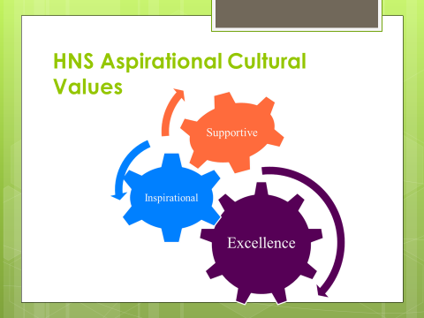

We are a community of professionals but also a community of learners.  Sharing struggles, successes and best practices with each other ultimately contributes to building a positive and supportive professional working environment.

We Are:



**W** – We Love our children

**I** – Innovation and Creativity

**N** – Non-Negotiation for student Achievement

**N** – No Excuses

**E** – Effort Reaps Rewards

**R** – Respect and resilience

**S** – Social responsibility and Justice

1. **After school and/ or summer program**

The After School ALC Program will provide coursework in reading and math for grades 3 – 8.

The program will provide math and reading intervention courses. Two days will be spent on reading and two days on math. Each content area will have a small group instructional day and an individualized computer day. During the after school class time students will have three different components:

• Reading and Math Fluency practice

• Small group direct instruction in math and reading

• Individual software support assigned to scholars

Each program location (2131 12th Avenue North/Penn and 1300 Olson Highway) has computer labs for scholars. Scholars will use math and reading software two days of the week and will engage in small group direct instruction. A two-tier bus system will operate to provide transportation for scholars engaging in the program: one will transport home K – 2 scholars and scholars who don’t qualify based on our guidelines for after school participation immediately after school at 3:45 p.m. At 4:45 p.m. an after-school bus will transport 3rd – 8th grade after school scholars. We will provide snack or dinner prior to dismissal.

After school programming will focus on “learning gaps,” specifically identified by the MAP data for scholars in grades 3 – 8 in reading and math; this is differentiated from the regular school day, which is focused on teaching grade-level standards. Students will be identified for the program based on MAP math and reading data and baseline assessments taken in classrooms. Technology to be utilized includes I Can Learn, Accelerated Math and Reading, IXL, and Moby Max. The intake process involves: a) Parents being notified of the assessment data; b) Teachers drafting a Continual Learning Plan (CLP); c) CLP is discussed and agreed to at parent conferences in September; d) Parent signs the CLP and after school ALC permission slip; and e) Scholar begins program.

The program will incorporate many best practices elements, including 15:1 scholar/teacher ratio (max of 22:1), high-quality staff development during the week of September 15, 2015 focused on math and reading interventions, and technology supports. We place special emphasis on hiring a staff that loves and cares for our scholars and places their academic success and social/emotional health first and foremost. Our vision is for every scholar to be at or above grade level, making steady and demonstrable progress towards that goal.

1. **Key successes from the past school year:**
2. Harvest Network of Schools continues to “Beat the Odds.” We exceeded the statewide math proficiency rates for African American students; We exceeded the Minneapolis district average in math and reading for African American students; We exceeded the Minneapolis district average for math and reading proficiency among low-income students; Our 5th grade ELL scholars were more than twice as likely as ELL students statewide to be proficient in math and reading.
3. Harvest Network of continues to be among the top performers in North Minneapolis. Our scholars out performed ALL but one Minneapolis Public School in north Minneapolis in math and reading.
4. Among our scholars, those who have been enrolled in the Harvest Network for more than one year did better academically.
5. Averaged over the past five years, 50% of Harvest Network scholars have tested at or above proficiency in math and reading
6. **Key challenges from past school year**
7. Like many schools, we’re still retooling our instructional approach to literacy in response to the Common Core standards. Schools statewide including ours experienced a drop in reading proficiency rates when the new standards were introduced in 2013.
8. Growing parent demand resulted in a significant increase in new and SPED student enrollment last year. We need to do a better job of accelerating new and SPED students toward proficiency faster.
9. Due to state cuts in Learning Year Funding, we didn't offer an extended school year for the first time in 2013-14. Sadly, the test results showed that summer learning loss (“summer slide”) had a significant impact on scholars returning in the fall of 2014. The summer of 2014 was the first year in seven years that summer school was not offered.
10. **Plan to address key challenges**

The plan to address these key challenges has been described in detail within the Academic Priorities document “Exhibit C” attached. Please refer to this document.

1. **Highlights of Schools Strategic Plan**

The Highlights of the school Strategic plan is also provided in the attached Academic Priorities document “Exhibit C”. Please refer to this document.

*HNS College Readiness Achievement priorities for the 2015-16 school year are:*

1. *Pace and align lesson and activities to increase general education and special education students’ proficiency on MN ELA Common Core Standards*
2. *Pace and align lesson and activities to increase general education and special education students’ proficiency on MN Math standards.*
3. *Develop, implement and evaluate effective intervention across the network though the GMS, After School Intervention, and NSNP program*
4. *Align classroom and cultural practices to reduce student reduce discipline incidents and off task behavior*

*In order to accomplish these College Readiness Achievement Goals there will be intentional focus on set priorities in each domain.*

1. *Pace and align lesson and activities to increase general education and special education students proficiency on MN ELA Common Core Standards Rationale and Priorities*

Prior to 2013 the HNS team invested an extensive amount time aligning the curriculum, (both math and reading) to the Minnesota state standards resulting in instructional delivery that yielded high proficiency results on the state wide assessments. Each grade level had Curriculum Alignment Tools, Pacing Guides, Comprehensive Assessments and lessons deliberately planned to ensure scholars were performing at the rigor required by the state. In 2013, Minnesota adopted new reading standards aligned with Common Core. In the same year, HNS selected a new reading curriculum- Journeys. Due to unknown rigor on the new Minnesota Comprehensive Assessment, a decision was made to advance the reading program in 2013 i.e. Third graders were taught using fourth grade curriculum. Feedback from lead reading teachers concluded that the curriculum was too difficult for the scholars to access. In to 2014-15 a decision was made not to advance the curriculum without sufficient due diligence of truly examining the reading curriculum through the view of the Curriculum Alignment Tool. Despite the advancement and non-advancement of the curriculum student proficiency scores continued to decline drastically. Both methods were only implemented for a year timeframe so there is very little evidence of whether advancing or the non-advancement of the curriculum was effective. This year will be the 2nd year of non-advancement of the Journeys Curriculum (See graph that follows).

*In addition to changing key curriculum components we adopted the Step Assessment. Step Assessments provides insight on scholars K-2 ability to comprehend text. Despite best efforts, responding to the results in an impactful way has been limited resulting in less scholars particular in 1st grade meeting their growth targets. The network struggled to acquire the resources (i.e. book sets, lesson plans, observation for improvement)needed to address bottom lines of Step in a systematic way, while ensuring that our K-2 Direct Instruction program wasn’t negatively impacted due to scheduling. Rookie teachers had a difficult time adjusting to the amount of planning needed to provide instructional plans for both guided reading and comprehension lessons. HNS also struggled with having adequate leadership band-with and transition to monitor and follow up with effective implementation and practice (See graph that follows).*

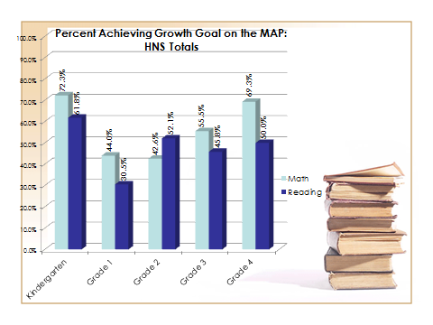

*As a growing network, decision- rights at time were unclear which led to many discussions about individual school independent decision making in terms of schedule and data team implementation. This resulted in implementation of inconsistent scheduling for core content areas and at the beginning of the year data team meetings initially being conducted and implemented by principals and data team leaders inconsistently. The CAO also noted that examining student work was a huge missing factor during these meeting. Teachers were only required to bring trackers and the assessment. Some of our core foundational instructional practices used in the past that needed to continue stopped.*

*Decision-rights and communication gaps occurred and posed challenges for the Direct Instruction Team to provide coaching. In transparency, most of their time was dedicated to serving groups unassigned (No other teacher available to teach them due to the time allocation for Direct Instruction at each school. Data for the last two years indicates that Direct Instruction Programs gains as anticipated are not occurring. Anecdotal observations indicate that teachers lack practice and feedback needed to execute the program well.*

*HNS has recognized that the intentionality of reading practices have to change in order to prepare our scholars to be successful on summative assessments, college and beyond. In efforts to change scholars’ outcome and preparedness we will focus on the following action steps:*

* *Develop Curriculum Alignment Tools, Pacing Guide, Assessments and Lesson plans aligned with Common Core Reading* **(feasible and ambitious)**
* *Increased inclusive Student Work Analysis during the Data Analysis Meetings in Reading***(feasible)**
* *Increase effective face to face feedback on Step Bottom Line and classroom reading practices* **(feasible)**
* *Establish clear expectations for school leaders to monitor DI and provide consistent feedback and coaching on the Direct Instruction Program* **(feasible)**
* *Implement and monitor Drop Everything and Read (D.E.A.R.) sustained silent reading supported by the Accelerated Reading Program* **(feasible and ambitious)**

*By focusing on these instructional priorities, the HNS Instructional Leadership Team will able to assess the comprehensiveness of the reading curriculum and really determine if it meets the needs of our scholars’ academic rigor. The purpose of the curriculum alignment tool is to ensure that the standards are thoroughly covered and identify gaps in the curriculum gone unnoticed. Additionally, by restructuring data meetings with an emphasis on gap analysis and examining student work, appropriate intervention for scholars who are struggling on standards can be intentionally assigned. Finally we have implemented the practice of giving in the moment and face to face feedback to teachers. The past 2 years, due to leadership changes and scheduling it has been inconsistently implemented with an emphasis on management. Focusing informal observation on our reading practices will support teaching staff in developing expertise in this content area. Finally, through observation the HNS district recognizes that teaching staff has done a lot of the heavy lifting and little support of independent sustained reading for scholars. The HNS Instructional Leadership Team believes that by shifting this cognitive lift to scholars it will support our efforts of increasing scholars’ ability to access the text.*

1. ***Pace and align lesson and activities to increase general education and special education students’ proficiency on MN Math standards.***

*HNS administrators have noticed a steady decline in MCA and Map math proficiency and growth data. As the trend data indicates below. In 2012, 77% of HNS scholars were proficient; it was also the first and only time MDE gave schools at least 3 opportunities to take the assessment. HNS had time during these 3 opportunities to provide standard base intervention and it was effective. In 2013, MDE did not offer the same opportunity and so administrators elected to go back to paper based testing. This was decided because paper test administration was what HNS scholars were most familiar with throughout the year. Years 2014 and 2015 tests were administered via computer and though there was a significant increase in 2014 proficiency scores plummeted in 2015.*

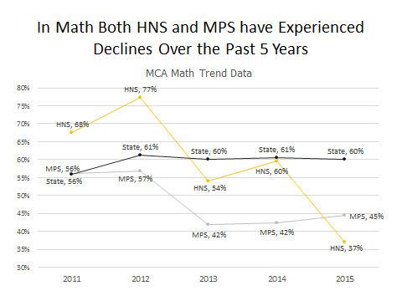

*Similar to reading, it has been awhile since our schools had revisited the curriculum alignment tool to ensure it was being followed are implemented correctly. This along with very few opportunities for teachers to engage in math professional development could very well be the reason HNS proficiency scores have declined.*

*HNS is also concerned about Math and Reading special education programming. In addition to the increase in the student and special education population, the state required special education to take the same assessment as their other regular education peers without modification. A significant amount of HNS special education scholars didn’t pass the MCA. There are 3 root causes for this outcome in addition to being administered an unmodified assessment. First,* ***teacher instability for special education across the network was an ongoing concern throughout the year****. During some parts of the school year, it was difficult to find licensed sped teachers to provide the services. This was addressed by providing variances for some staff members with limited special education experience. The special education population was an accumulation of many different disabilities but* ***many of our special educations need behavioral support.*** *There was only a limited number of staff members with the* ***training needed to deescalate behaviors*** *and frequently those scholars were suspended from school or assigned to self-contained classrooms.*

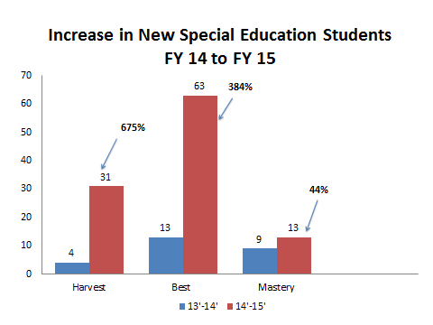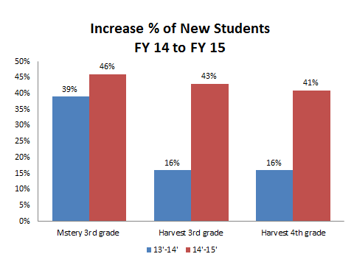

*.HNS has recognized that the following action steps will support an increase in math proficiency:*

* *Create a HNS Math Instructional framework for grades k-4 & 6-8*
* *Develop Curriculum Alignment Tools, Pacing Guide, Assessments and Lesson plans aligned with MN Math standards* **(feasible and ambitious)**
* *Increased math professional development opportunities for the HNS staff throughout school year*
* *Increased inclusive Student Work Analysis during the Data Analysis Meetings in Reading***(feasible)**

1. ***Develop implement and evaluate effective intervention across the network though the GMS, After School Intervention, and NSNP program for Reading and Math.***

*Strong core academic instruction that is rigorous and well-delivered is the best way to support all scholars. At the same time, HNS recognizes that scholars need additional support academically to provide targeted support, ensure learning growth and continuous progress. Academic Intervention, however, have been inconsistently implemented across the network and tracked inconsistently for progress for several reasons. Ineffective planning prior to the school year starting with all schools, leadership support (such as training, no observation and no consistent data collection) and implementation of the intervention programs varied and limited human resources for implementation negatively impacted the programs being implemented strategically and consistently across the network. As a result, it was difficult to determine what impact the interventions had on scholars throughout the year.* ***It also resulted in some scholars not receiving any additional academic support throughout the year.***

*Additionally, the network has purchased several software programs to support individual learning: Accelerated Reading, Moby Max, and IXL. Yet we have not maximized these resources in an effective manner. This is partially due to the lack of hardware provided in the classroom. Another root cause is not being intentional about when and how the software should be utilized in classrooms and during interventions.*

*The final root cause for ineffective intervention programing was not clearly distinguishing between Growth Mindset Club and No Struggle No Progress Friday intervention program for the schools. Not doing this made it difficult to truly determine the needs for support and resulted in the Friday Program and GMC being understaffed in some school and underutilized volunteers. Research has shown that effective interventions can have a significant impact on student growth with intentional planning and monitoring occurs. So in an effort to ensure that scholars are receiving in consistent effective intervention we will have the following action steps:*

* *Clarify interventions expectations for each type and differentiate the purpose, structure and resources for the 3 programs within the schools* **(feasible)**
* *Track student intervention and progress* **(feasible and ambitious)**
* *Train staff and volunteers on resources to effectively provide intervention* **(feasible and ambitious)**
* *Examine, Modify and Implement Individual Education Plans that will have high level considerations for grade level standards* **(feasible and ambitious)** and provide academic intervention for all scholars

*The HNS Leadership Team are in discussion and the finalization phase of how the 4 types of interventions will be implemented throughout the building. Thus far we have consensus on the following:*

|  |  |  |  |  |  |
| --- | --- | --- | --- | --- | --- |
| *Type of Intervention* | *Purpose* | *People* | *Resources* | *Implementation Days* | *School Leadership Responsibility* |
| *August Interventions* | *Review of standards not met during the previous year based on Map Data 1st-8th. This also includes term 5 assessment data of students that are returning.* | *Teachers will provide this intervention during the day for a 3 week period*  *Time will vary by grade level* | *\*Current Past Year Curriculum*  *\*Map Data*  *\*Intervention Planning Time during the 2nd week of PD*  *\*1st week- base line data* | *August 10th-31st* | *Review Intervention Plans*  *Conduct Intervention Observation*  *Analyze Assessment Data to determine impact* |
| *Growth Mindset Club (GMC) (transitional- scholars flow in out of GMC as needed)* | *Provide grade level standard intervention based on the interim assessment for 3-4 Harvest and Mastery, 3-6 Best Academy East and 3-4 Best Academy*   * *It was a desire to do this program up to 8th grade but resources are questionable at this point? We may not have enough staffing to support the GMC program 5-8* | *Title 1 Teachers*  *Instructional Coaches*  *Academic Interventionists* | *\*Scholars Interim Assessment*  *\*Curriculum*  *\*Interventionist Made Resources*  *\*Fluency Foundational Skills with a focus on number sense/grade level material*  *\*IXL* | *Beginning in October during scholars prep 2 days for Reading and 2 days for Math- Monday – Thursday through spring break at the end of the school year.* | *Create and/or approve Academic Interventionist and Title 1 Scheduling*  *Logistically plan transitions, rewards and resources to support the program*  Create and distribute reporting process for attendance, assessments and evaluation of program implementation |
| *M- Th After School Intervention Program* | *Provide intervention for 3rd-8th grader (All Schools) on both current and past academic standards not mastered*  *12-1 ratio Technology Focused* | *Teaching Staff- Teachers will be assigned once a week to support the intervention program*  *Volunteers*  *School Counselors*  *Social Workers*  *Psychologist* | *\*Moby Max*  *\*Accelerated Math and Reading*  *\*I Can Learn* | *October 3:45-4:45* | *Determine enrollment criteria*  *Ensure that CLPs are completed for students with appropriate signatures*  *Create calendar for intervention training*  *Plan logistical implementation with leadership team*  *Send out communication for parents* |
| *No Struggle No Progress (NSNP)* | *Provide Intervention Math and Reading*  *(We are still determining criteria and grade for scholars)* | *Academic Interventionists*  *Title I Teachers*  *Social Workers*  *Educational Assistants*  *Paras* | *\*Moby Max*  *Need to look at resources for reading and transportation* | *October 1:45-4:45 Fridays only* | *Determine enrollment criteria*  *Ensure that CLPs are completed for students with appropriate signatures*  *Create calendar for intervention training*  *Plan logistical implementation with leadership team*  *Send out communication for parents* |

1. ***Align classroom and cultural practice to reduce student inappropriate behaviors and increase instructional time.***

*Our ability to define our student culture has much to do with how successful we are in educating our scholars. Between August-December 2014, the district had over 150 suspensions. We decreased our suspension rate from January to June of 2015 but at the cost continuous academic disruption while we attempted to implement alternative methods such as in school detention and focusing on parent involvement. This is particularly concerning because the average suspension lasts three days, which means those* ***scholars are not at school learning****. There are several contributing factors for our high rate of suspension.  One contributing factor was administration’s lack of alignment with recommended and past practices for behavioral support and its tracking. There was great confusion between deans vs. behavior specialists, and there is inconsistent use of the Nia Points system vs. Dojo points. As a result, behavior specialists initially were given the impression that they should only focus on high flyers and other behavior challenges. They were encouraged to let teachers deal with other scholars displaying similar behaviors. This was very different from the process last year, when teachers were encouraged to subtract Nia points, contact parents, use a buddy system, and once scholars reached a particular low score with Nia points they were sent to the dean and were not allowed to return to class. These inconsistent implementation practices resulted in staff members not knowing appropriate steps to get support and resulted in leaders spending more time intervening or addressing disruptive behaviors.*

*Another contributing factor is a* ***lack of understanding and monitoring of the Problem Solving Team process.*** *Staff members have expressed that though they have gone through steps, they feel as though they are not being supported. The Problem Solving Team has the philosophy that behavioral intervention, unless in extreme cases, are best implemented by the staff members in the classroom. The length of the process is also a concern. I was recently informed that it takes 2-6 weeks of intervention implementation before the Problem Solving Team can advance to the next step. If a scholar is recommended for Special Education it then takes an additional 30 days for testing. This is a tremendous amount of time, yet is required by the state, and it is our responsibility to ensure we have done everything we can before taking the very serious step of referring a child for a special education determination. We will need to find a way to support these scholars in the interim.*

*Another reason for increased suspension is* ***inconsistent execution of engagement and expectations in the classroom****. The majority of our classrooms still engage in teacher-directed learning versus student-directed learning. Scholars have limited structured engagement with each other. We have started the process of rolling out certain practices such as paper dissemination, snack procedures, and in-classroom transitions. We have yet to do that with engagement strategies such as turn and talk, habits of discussion, and polling the classroom; resulting in our scholars trying to find opportunities to engage with their peers and losing behavior points for minor offenses. Therefore we will engage in the following action steps:*

* *Implement with fidelity the Behavior Management Cycle process* **(feasible)**
* *Sharing Nguzo Saba Principles across the Network of Schools to develop and enhance character trait* **(feasible)**
* *Implement with fidelity the Nia Point Reward and Consequence System* **(ambitious)**
* *Conduct consistent Cultural Walks throughout the network and give feedback to the principals on monthly bases.* **(feasible)**
* *Effectively implement and utilize the problem solving team to ensure interventions designated are being conducted* **(feasible)**
* *Novice Teachers and Educational Professionals will receive additional training and practice monthly on the BMC*
* *Provide a broader group of staff members on de-escalation training who aid in supporting scholars who are having a difficult time with behaviors.* **(feasible)**

*Focusing on the priorities listed above will greatly improve student culture and ensure our scholars are in classrooms learning. It will support teachers in having a very systematic way of redirect off task behavior. Furthermore it will systematically reward scholars for demonstrating the behavior the network values.*

|  |  |  |  |
| --- | --- | --- | --- |
| **Priority 1:**  **Reading Instruction** | ***Pace and align lesson and activities to increase student proficiency on MN ELA Common Core Standards*** | | |
| *Further flesh this out—Using the questions below, consider what needs to be different in each of these areas to address this priority?* | | | |
| **In teaching (very concretely—in classes, what do you want to see)?** | | **In School Leadership (what do you want principals to be doing)** | **In the Instructional Model & Curriculum** |
| *CAT aligned with MN ELA Standards  *Pacing Guides provide a clear scope and sequence of standards being covered  *Effective detailed close reading lesson plans implemented 3x weekly  *Comprehension lesson engaging scholars in text dependent questions  *Guide Reading lesson focused on application  *Vocabulary study based on the main text in the curriculum  *Student work reflecting application of the skills taught throughout the week  *Increased proficiency scores on exit tickets, quizzes, and comps  *Written responses to reading | | *Informal and Formal observation reflecting observation on Reading Content  *Purposely led data team meeting with clear objectives, outcomes, and documented follow up based on student work and outcomes.  *Providing professional development and modeling on Close Reading, Guided Reading and Comprehension lesson  *Systematically monitoring to scholars reading progress through AR, Moby Max, quizzes and comps. | *Teachers will use the main story in the Journey’s text for the Close Reading Lesson  *Implementation of a 3 Day Close Reading Cycle including: first read, 2nd and 3rd read.  *Systematic rotation of Guided Reading and Comprehension lessons including text dependent questions with evidence  * Read Writing Responses |
| *Now, consider the network’s entry points: How then should the following organizational resources be used to make these changes happen?* | | | |

|  |  |  |  |
| --- | --- | --- | --- |
| **The Academic Team’s Time** | **Teacher & Leader PD/Support** | | **The CAO’s Time** |
| *The academic team (including principals, assistant principals, and instructional coaches) will focus on providing feedback on close reading content with individual teachers  *Executing purposeful data meeting analyzing inclusive student work and response to reading gaps  *Analyzing video for the learning gap  *Providing specific data to inform intervention to CAO and school leaders. (See HNS Reading Writing Framework and Grid)  *Provide feedback on core reading lesson plans | *Provide ongoing PD and lessons for Close Reading  *Provide comps, quizzes and exit tickets to assess scholars understanding  *implement lesson plan protocol review  *Assess and monitor progress of scholars  *Be intentional about analyzing special educational work samples in addition to general education work samples | | *1 on 1 meeting individual principals intentionally focused on Reading data to assist in determining the learning gap  *Providing feedback on effective feedback  *Observe and gather information determine how to allocate resources for support  *Develop the capacity of leadership to progress monitor throughout the term |
| **Big Wins:** *Restate the priority in terms of what you “win” on in this area of work:*  Intentional focus on Close Reading Lesson plan delivery and activities will increase scholars’ capacity to interpret and comprehend the text resulting in high quality response to text with supporting evidence. | | **Measures of Success/Progress Indicators:** *How will we know we are successful? On track?*  *Develop Curriculum Alignment Tools, Pacing Guide, Assessments and Lesson plans aligned with Common Core Reading* **(feasible and ambitious)**   * Each term teachers will engage in a “fishbowl,” process in which the content specialists will be given feedback on the Curriculum Alignment Tool, Interim Assessments, materials and activities they provide from the grade level team.   *Increased inclusive Student Work Analysis during the Data Analysis Meetings in Reading***(feasible)**   * Data Meeting will be videotaped to examine the gap analysis work conducted by grade level teams * Submission of in class intervention will be spot checked to ensure that they are aligned with the gap analysis   *Increase effective face to face feedback on Step Bottom Line and classroom reading practices* **(feasible)**   * Teach Point Data will be monitored to ensure both face to face and informal observation are conducted on reading and Step Bottom Line   *Establish clear expectations for school leaders to monitor DI and provide consistent feedback and coaching on the Direct Instruction Program* **(feasible)**   * The DI Coordinator will monitor DI binders that provides progress on every 5th lesson and provide information to principals every 3 weeks or when information is not made available   *Implement and monitor Drop Everything and Read (D.E.A.R.) sustained silent reading supported by the Accelerated Reading Program* **(feasible and ambitious)**   * Goals are made for each individual grade. * Principals will pull AR reports from their classrooms to determine students’ progress towards the goal. | |

|  |  |  |  |  |
| --- | --- | --- | --- | --- |
| **Priority 2:**  **Math Instruction** | *Describe the desired change/what you want to see happen:*  ***Pace and align lesson and activities to increase general education and special education students’ proficiency on MN Math standards.*** | | | |
| *Further flesh this out—Using the questions below, consider what needs to be different in each of these areas to address this priority?* | | | | |
| **In teaching (very concretely—in classes, what do you want to see)?** | | **In School Leadership (what do you want principals to be doing)** | | **In the Instructional Model & Curriculum** |
| *Increased math professional development opportunities for the HNS staff throughout school year | | *\*Develop Curriculum Alignment Tools, Pacing Guide, Assessments and Lesson plans aligned with MN Math standards* (feasible and ambitious) | | *Create a HNS Math Instructional Framework for grades K-4 & 6-8 |
| *Now, consider the network’s entry points: How then should the following organizational resources be used to make these changes happen?* | | | | |
| **The Academic Team’s Time** | | **Teacher & Leader PD/Support** | | **The CAO’s Time** |
| *The academic team (including principals, assistant principals, and instructional coaches) will focus on providing feedback on close reading content with individual teachers  *Executing purposeful data meeting analyzing inclusive student work and response to reading gaps | | *Provide ongoing PD and lessons for Close Reading  *Provide comps, quizzes and exit tickets to assess scholars understanding  *implement lesson plan protocol review  *Assess and monitor progress of scholars  *Be intentional about analyzing special educational work samples in addition to general education work samples | | *Collaborate and research best instructional frameworks for math  *With experts, develop a K-4 and 5-8 Math Framework |
| **Big Wins:** *Restate the priority in terms of what you “win” on in this area of work:*  Creating a mathematical framework, increasing opportunities for staff development and aligning math materials and activities with MN standards will increase proficiency | | | .**Measures of Success/Progress Indicators:** *How will we know we are successful? On track?*  *Create HNS Math Instructional framework for grades k-4 & 6-8*   * A document clearly outline the HNS Math Instructional Framework for grades K-8   *Develop Curriculum Alignment Tools, Pacing Guide, Assessments and Lesson plans aligned with MN Math standards* **(feasible and ambitious)**   * Each term teachers will engage in a “fishbowl,” process in which the content specialists will be given feedback on the Curriculum Alignment Tool, Interim Assessments, materials and activities they provide from the grade level team.   *Increased math professional development opportunities for the HNS staff throughout school year*   * Professional Development Document will reflect math training opportunities for teaching staff   *Increased inclusive Student Work Analysis during the Data Analysis Meetings in Reading***(feasible)**   * Data Meeting will be videotaped to examine the gap analysis work conducted by grade level teams * Submission of in class intervention will be spot checked to ensure that they are aligned with the gap analysis | |

|  |  |  |  |  |
| --- | --- | --- | --- | --- |
| **Priority 3:**  **Effective Intervention** | ***Develop, implement and evaluate effective intervention across the network though the GMS, After School Intervention, and NSNP program*** | | | |
| **In teaching (very concretely—in classes, what do you want to see)?** | | **In School Leadership (what do you want principals to be doing)** | | **In the Instructional Model & Curriculum** |
| *Timely and consistent reporting of student outcome through software and/or academic trackers  *Grouping scholars according to standards of need  *Analyzing student work to determine the gap | | *Allocating time and resources to support effective intervention programming  *supporting staff members in progress monitoring academic student support  *Recognizing and adjusting intervention based on effectiveness | | *Facilitate the development of the intervention model based on scholars outcomes and needs, including clear triggers  *Holding leaders accountable to effective intervention implementation and planning  *Troubleshooting in collaboration with leaders on how to problem solve if intervention implementation is experiencing difficulty  *Evaluate effectiveness |
| *Now, consider the network’s entry points: How then should the following organizational resources be used to make these changes happen?* | | | | |
| **The Academic Team’s Time** | | **Teacher & Leader PD/Support** | | **The CAO’s Time** |
| *Examining student work  *creating effective interventions or manipulating the software to accommodate scholars’ needs  *Reporting scope creeps and challenges that may hinder appropriate implementation | | *Providing feedback on effectiveness of intervention implementation  *Scheduling resource allocation to support intervention efforts  *Problem solve and monitor progress consistently | | *Analyze schools implementation of intervention to ensure equity and alignment  *Conference, advice and support key decisions that ensure the fidelity of implementation in regards to material use and staff allocation |
| **Big Wins:** *Restate the priority in terms of what you “win” on in this area of work:*  Providing intentional intervention programing across schools will provide another opportunity to close significant gaps in student learning when we implement monitoring protocols to ensure tracking and give intentional responses to the needs of the students. | | | **Measures of Success/Progress Indicators:** *How will we know we are successful? On track?*  *Clarify interventions expectations for each type and differentiate the purpose, structure and resources for the 3 programs within the schools* **(feasible)**   * A intervention course description will be documented and shared with HNS by week of September 15th   *Track student intervention and progress* **(feasible and ambitious)**   * A metrics will be developed to report students ongoing process through exit tickets and intervention software   *Train staff and volunteers on resources to effectively provide intervention* **(feasible and ambitious)**   * Professional development document will reflect training along with training decks as evidence of training.   *Examine, Modify and Implement Individual Education Plans that will have high level considerations for grade level standards* **(feasible and ambitious)** and provide academic intervention for all scholars   * Document will be provided, demonstrating review of IEP’s and their modification to include state standards and interventions if applicable. | |

|  |  |  |  |  |
| --- | --- | --- | --- | --- |
| **Priority 4:**  **School Culture Alignment** | *Describe the desired change/what you want to see happen:*  ***Align classroom and cultural practices to reduce student reduce student discipline incidents and increase student engagement.*** | | | |
| *Further flesh this out—Using the questions below, consider what needs to be different in each of these areas to address this priority?* | | | | |
| **In teaching (very concretely—in classes, what do you want to see)?** | | **In School Leadership (what do you want principals to be doing)** | | **In the Instructional Model & Curriculum** |
| *Consistently and systematically executing the Behavior Management Cycle  *Effectively implementing the Nia Point Reward and Consequence System  *Effectively implementing classroom wide procedure to eliminate or minimize distraction from student learning.  *Setting clear expectations and rules to create order in the classroom | | *Providing cultural leadership through community meeting emphasizing values and character development  *Providing modeling and in the moment feedback on classroom management techniques  *Getting students invested in the culture of the school is more than techniques to management behavior. *The team has to determine what kind of culture they want for the students and put rituals and practices in place to reinforce the behaviors you want. | | The Behavior Management Cycle is a fundamental roadmap that outlines the steps a teacher takes to create conditions for success for students The Principle of the Behavior Management Cycle is for Teachers, Administrators, and HNS Staff Members to uniformly execute; proactive, positively-framed, set of expectations. The cycle has five associated components that are designed to provide a straightforward process for behavior expectations. The cycle instructs and prepares Classroom Leaders and Instructional Staff members to proactively set behavior expectations, consistently apply consequences, and reinforce the desired behaviors from our scholars; in our classrooms and common areas such as; hallways, cafeteria, etc. Effective utilization of the BMC will ensure we have a unified mode of conduct and consistent intervention protocols.  There are five components of the BMC; each component is supported by identified and practiced skills and competencies so support confidence and execution. All components of the BMC will be trained in a modular framework.  Components  Assertive Authority  Proactive Expectations  Issuing a Consequences  Reinforce Expectations  Redirect Non-Compliant Behavior |
| *Now, consider the network’s entry points: How then should the following organizational resources be used to make these changes happen?* | | | | |
| **The Academic Team’s Time** | | **Teacher & Leader PD/Support** | | **The CAO’s Time** |
| *Attend Professional Development Session to the Behavior Management Model  *Write scripts and/or lesson for key procedures and protocols in the classroom  *Provide incentives and rewards for on task behavior  *Utilize TLAC techniques to maximize learning time. | | *Immediately correcting any misbehaviors or conduct that will negatively impact the school culture  *Frequently monitoring and evaluating points earned by scholars on the Nia Tracker to capture trends for further Professional Development  *Teachers and school leaders meeting to determine what and how are they going to get students more invested in the school. | | *Conducting Cultural Walks with leaders to ensure alignment of expectation  *Analyzing Nia Data for the Network to determine network trends for professional development  *Provide tactical support for the principals to ensure stakeholder alignment |
| **Big Wins:** *Restate the priority in terms of what you “win” on in this area of work:*  Implementation of the network behavior cycle and consistent aligned standards and practice will support a positive school climate resulting in more scholars time spent on academic task. | | | **Measures of Success/Progress Indicators:** *How will we know we are successful? On track?*  *Sharing Nguzo Saba Principles across the Network of Schools to develop and enhance character trait* **(feasible)**   * Calendar reflecting monthly principle focus and community meeting focus.   *Implement with fidelity the Nia Point Reward and Consequence System* **(ambitious)**   * Google doc tracking the Nia Points and frequent reports of referrals and suspensions.   *Conduct consistent Cultural Walks throughout the network and give feedback to the principals on monthly bases.* **(feasible)**   * Monthly Summary of Cultural Walks   *Effectively implement and utilize the problem solving team to ensure interventions designated are being conducted* **(feasible)**   * *?*   *Novice Teachers and Educational Professionals will receive additional training and practice monthly on the BMC. Provide a broader group of staff members on de-escalation training who aid in supporting scholars who are having a difficult time with behaviors.* **(feasible)**   * Professional develop document will reflect training for BMC and De-Escalation Training. | |

**Administrator’s Professional Development**

**Eric Mahmoud – Principal Best Academy**

**Charter Network Accelerator – 18 month CEO Fellowship**

**September 2014 – 3 day seminar in Memphis, TN for educational leaders**

Topics;

Organizational Culture – Analysis of organizational survey data from staff

Team and Talent – Readings: Conversational Capacity and Situational Leadership

Organizational planning – Annual planning cycle

Change management - Readings: Switch

**December 2014 – 3 day seminar in New York**

Topics:

Meeting The College Ready Bar – Review Common Core ELA standards and effective approaches

Team and Talent – Readings: Five Dysfunctions Of A Team

Personal Leadership Development - Readings – Primal Leadership

Executive coaching

**April 2015 – 3 day seminar in New York**

Topics:

Meeting the College bar – Site visits to High performing charter schools such as Uncommon schools and Achievement First. Workshops on meeting Common Core standards in reading and math

Personal Leadership Development – Workshops on leading teams

Ongoing Executive Coaching every 2 weeks for the entire 14’ – 15’ school year

Fatou Diahame – Principal Best Academy

RELAY GRE – National Principals Fellowship – 1 year training

In partnership with Uncommon Schools, Relay created a new kind of principal training program, designed specifically for current principals: a one-year National Principals Academy Fellowship (NPAF) that prepares principals to become instructional and cultural leaders, not merely building managers. Now in its second year, NPAF is training nearly 200 leaders from 18 states and 32 school districts to improve the lives of more than 100,000 students across the United States. School leaders attend a two-week summer intensive in New York City or Denver, and four weekend “intersessions” throughout the year in New York City.

Like all Relay programs, the NPAF approach emphasizes individualized, job-embedded practice. School leaders study their “game film”: they record their feedback and professional development sessions with colleagues, analyze them with faculty members, practice new approaches, and immediately apply what they learn to their own school contexts. We also realize that the principal managers at the district and organizational level are key partners in our work, and require that they attend key sessions during the summer in order to better support NPAF participants throughout the year.

Topics covered:

* Instructional leadership
* Coaching
* Meeting Common Core Reading and Math standards
* Data analysis
* Leading teams

**Capture the other issues that are important but not priorities right now:**

***Low-Hanging Fruit—What can we fix easily right now that will have a positive impact?***

We need to support scholars in academic technology development. A term of computer class and 3 opportunities to be assessed via computer is not efficient to gain the needed skills to manipulate the technology as a learning device.

We need to some evaluate if in fact the computer test taking strategies supported or provided a hindrance to the newly administered summative assessment. The network needs to schedule and ensure practice time for test in the spring.

***Important but Not Yet- What do we believe is important and want to do but are intentionally delaying?***

Eventually it will be important to develop an academic program supported by technology devices effectively.

***What are we saying “no” to right now?***

HNS will focus on reading with the belief that skills gained by scholars will assist in other subject areas including Math, Social Studies and Science***.***

***What do we need to stop doing so that we can focus on our priorities?***

HNS leaders will ensure to engage in authentic gap analysis in data team meetings.

Observations must consist of Reading Objectives with content specific feedback. Consistent implementation of the behavior system in special education must be focused on academic priorities with teachers being required to provide academic instructions***.***

**7. Academic Performance: Goals & Benchmarks**

**Best Academy Progress on ACNW Contractual Academic Goals & WBWF Alignment**





Summary: The purpose of this section of the report is to inform stakeholders about our school academic performance on ACNW contractual goals. These goals include: Ready for Kindergarten, Reading Well by 3rd Grade, Achievement Gap Closure and Career and College Ready.

*Best Academy Ready for Kindergarten* goal was to ensure that all kindergarten scholars were ready for kindergarten. This is usually indicated by the NWEA Map Data in the area of Math and Reading. The Map Assessment measures growth over time, generally from the winter to the spring. For 2014-15 school year 100% of Best Academy scholars did not demonstrate one year of growth according to the Map Assessment. According to the Map 70.4% of Best’s scholars achieved their growth goal in Math and 59% in reading. Please refer to the chart directly above.

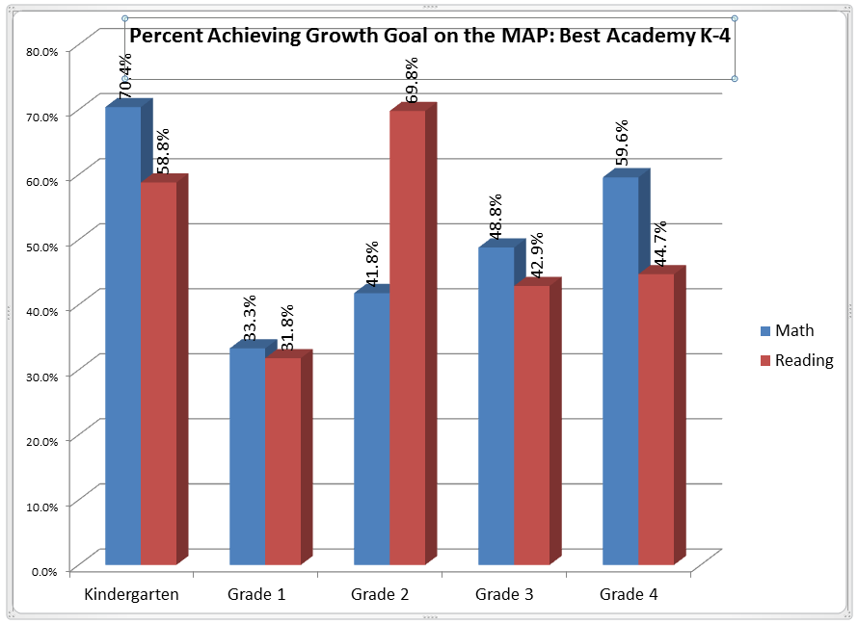

Best Academy next ACNW contractual goal reflects our ambition towards 3rd grade reading preparedness. Best wants all 3rd grade scholars to be literate. Unfortunately, Best Academy did not make significant progress in this area as hoped. As indicated below only 28% of our scholar met or exceeded o the reading assessment.

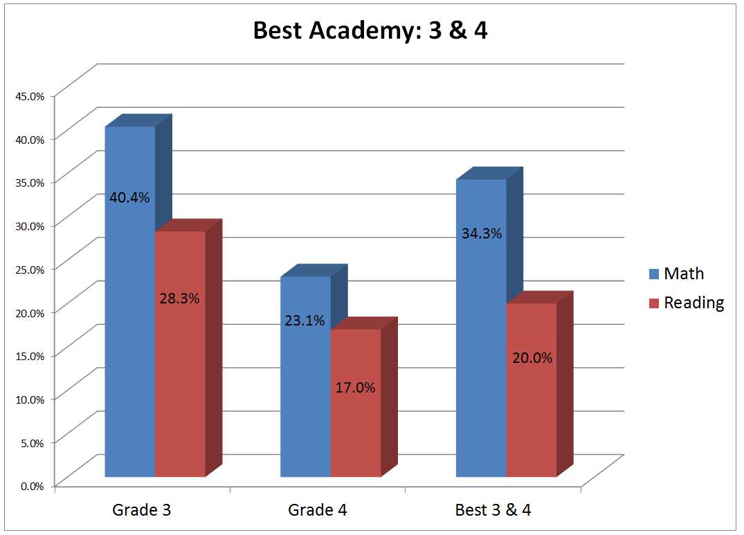

Another ACNW contractual goal that we value is achieving gap closure between racial and economic achievement outcomes. In order to determine this Best Academy compares its academic performance against state wide data. The comparison includes comparing African American scholar’s with their Caucasian peers. Best Academy scholar’s performance indicates, in comparison to past years, that the gap has widened due to this year’s performance. According to the data….

*Career and College Ready* is the ultimate goal for Best Academy scholars. In the fore mentioned paragraph, it is made clear that Best Academy has much work to do to achieve this goal. As a result Best Academy, a school affiliated with Harvest Network of Schools, have created an Academic Priorities document and plan to for this upcoming year to improve scholars performance in all grades.

**Indicator 1: Mission Related**

Goal: Best Academy mission is to instruct, empower, enable and guide scholars to achieve superior academic, **social and moral development**.

Best has been working diligently on decreasing our school suspension and increasing social and moral development so that school culture will support academic growth. According to our suspension data submitted to Minnesota Department of Education there has been a ____________ in Best Academy suspension data from 2014-15 to 2015-16 as depicted in the graph below.

**Indicator 2: English Language Learners**

WAITING FOR RESPONSE

**Indicator 3 and 4: Reading and Math Growth**

Each year during the contract period, on average is that 65% of all students tested in the fall and spring will meet expected fall to spring growth targets as measured by the NWEA Map Assessment in both Math and Reading. Best Academy did not meet its expected outcome as indicated in the next 2 charts for either subject areas. The highest performing grade was 2nd grade and 8th grade in Reading. More grades met the growth goal in Math including: Kindergarten and 7th grade made the targeted growth goal. Grades 5th and 6th were also very close to meeting the goal for Math.

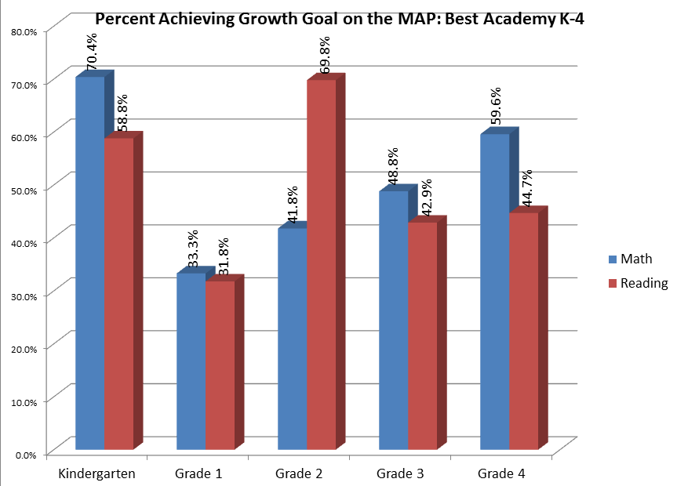

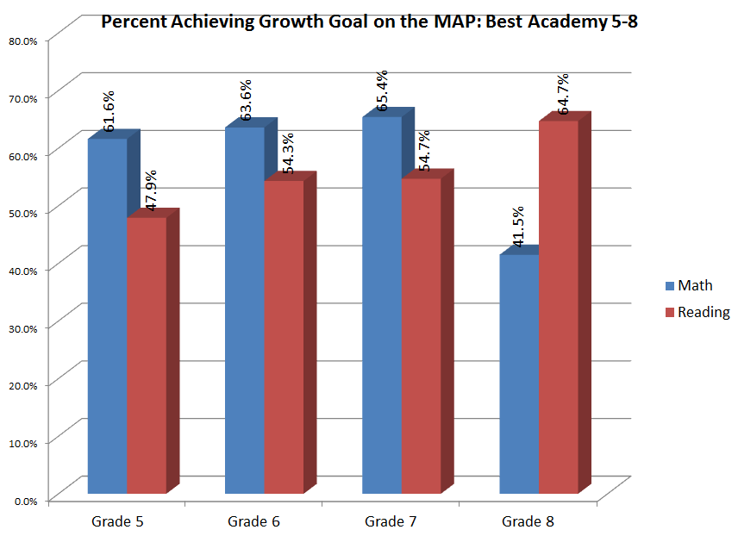

**Indicator 5 & 6: Math and Reading Proficiency**

*ACNW Goals Chart*

|  |  |  |  |  |  |  |
| --- | --- | --- | --- | --- | --- | --- |
|  | Baseline (2013) | 14-15 | 15-16 | 16-17 | 17-18 | 18-19 |
| Math Proficiency | 53% | 60% | 65% | 70% | 75% | 80% |
| Reading Proficiency | 41% | 50% | 55% | 60% | 65% | 70% |

Best Academy ACNW contractual goal for Math and Reading proficiency goal for the 14-15 school-year was to gain 65% proficiency in Math and 55% proficiency in Reading. Best Academy did not acquire the goals desired this year as indicated in the next two graphs. Overall Best Academy proficiency score for Math for the 2015-16 school year is 32.2%. For Reading 35% of Best Academy scholars were proficient.

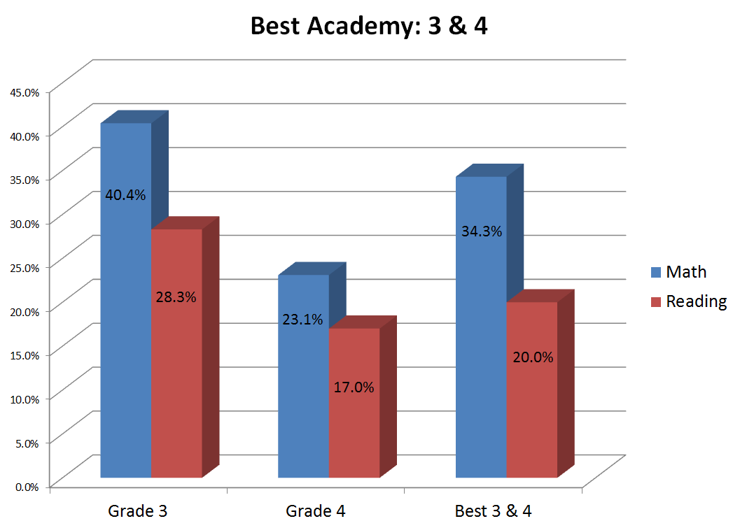

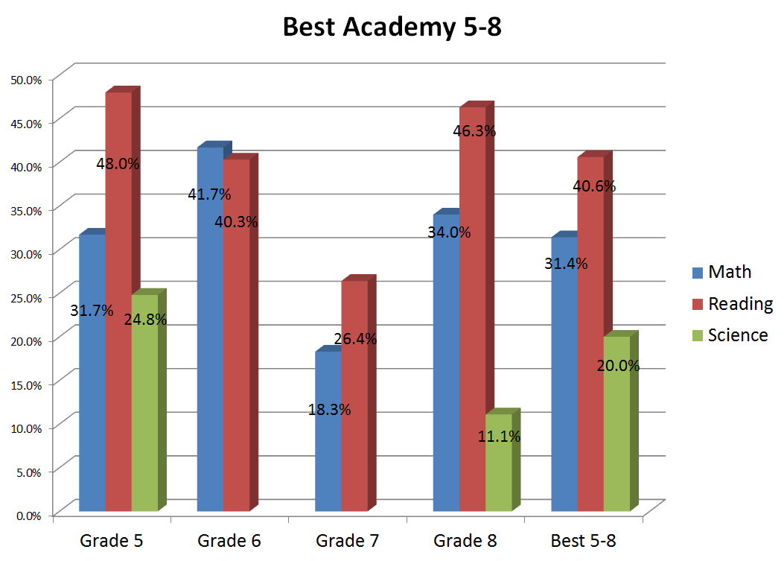

**Indicator 7: Science Proficiency**

Science is an essential part of the Best Academy Curriculum. Scholars take the Science State Assessment in the 5th and 8th grade. Approximately 25% of our scholar met or exceeded on the Science Statewide Assessment. There were 11% of the 8th grade Best Academy scholars who were proficient on the statewide Science Assessment. This is depicted in the graph below with the green bars.

In conclusion there are many factors contributing to these outcomes as explained in the 2015-16 Academic Priorities document. A brief description of our challenges will be provided in this section.

***Decrease in Reading Growth and Proficiency***

Prior to 2013 the HNS team invested an extensive amount time aligning the curriculum, (both math and reading) to the Minnesota state standards resulting in instructional delivery that yielded high proficiency results on the state wide assessments. Each grade level had Curriculum Alignment Tools, Pacing Guides, Comprehensive Assessments and lessons deliberately planned to ensure scholars were performing at the rigor required by the state. In 2013, Minnesota adopted new reading standards aligned with Common Core. In the same year, HNS selected a new reading curriculum- Journeys.

Due to unknown rigor on the new Minnesota Comprehensive Assessment (a summative assessment for the state) a decision was made to advance the reading program in 2013 i.e. Third graders were taught using fourth grade curriculum. Feedback from lead reading teachers concluded that the curriculum was too difficult for the scholars to access. In to 2014-15 a decision was made not to advance the curriculum without sufficient due diligence of truly examining the reading curriculum through the view of the Curriculum Alignment Tool. Despite the advancement and non-advancement of the curriculum student proficiency scores continued to decline drastically.

In addition to changing key curriculum components we adopted the Step Assessment. Step Assessments provides insight on scholars K-2 ability to comprehend text. Despite best efforts, responding to the results in an impactful way has been limited resulting in less scholars particular in 1st grade meeting their growth targets. The network struggled to acquire the resources (i.e. book sets, lesson plans, observation for improvement)needed to address bottom lines of Step in a systematic way, while ensuring that our K-2 Direct Instruction program wasn’t negatively impacted due to scheduling. Rookie teachers had a difficult time adjusting to the amount of planning needed to provide instructional plans for both guided reading and comprehension lesson. HNS also struggled with having adequate leadership band-with and transition to monitor and follow up with effective implementation and practice.

***Decrease in Math Growth and Proficiency***

HNS administrators have noticed a steady decline in MCA and Map math proficiency and growth data. As the trend data indicates below. In 2012, 77% of HNS scholars were proficient; it was also the first and only time MDE gave schools at least 3 opportunities to take the assessment. HNS had time during these 3 opportunities to provide standard base intervention and it was effective. In 2013, MDE did not offer the same opportunity and so administrators elected to go back to paper based testing. This was decided because paper test administration was what HNS scholars were most familiar with throughout the year. Years 2014 and 2015 tests were administered via computer and though there was a significant increase in 2014 proficiency scores plummeted in 2015.

Similar to reading, it has been awhile since our schools had revisited the curriculum alignment tool to ensure it was being followed are implemented correctly. This along with very few opportunities for teachers to engage in math professional development could very well be the reason HNS proficiency scores have declined.

Though Best Academy has been challenged by these obstacles and have decreased in growth and proficiency in Math and Reading, the academic priorities that the staff have development gives them confidence that significant growth and proficiency will be achieved this year.

## The GAP Closing Framework

Harvest Prep and Best Academy use an educational model patterned after high-performing public schools. It is built around the five essential questions that have been repeatedly mentioned, taken from Richard Dufour’s book, *Learning by Doing.[1]* Schools that have answer these five essential questions have demonstrated success serving children from low-income backgrounds.

1. What do my students need to know and be able to do?
2. What are the most effective ways to teach what they need to know?
3. How do I know that they got it?
4. If they didn’t get it after I taught it, then what?
5. What if they have already mastered the material before I taught it?

To answer these five questions, Harvest Prep and Best Academy use the Gap Closing Framework illustrated below. It is designed from the inside out and organized around a set of concentric rings. Because student achievement is the *sine qua non* of teaching, student achievement is found at the center of the ring. Because the greatest lever that influences student achievement is teaching, the teaching ring is placed in symbiotic relationship with the core of the framework, with student achievement*.*

The teaching ring is composed of (a) Planning, (b) Teaching and Re-teaching, (c) Assessment, (d) Reflection and Student Support Systems (abbreviated as S3). Everything in the middle and outer rings supports teaching and learning. The middle ring of administration, supports teaching. The administrative ring is composed of Instructional Leadership, Formal and Informal Observations, Instructional Coaching, and Data Analysis and Coaching. The outer ring, which supports teaching and administration, consists of the academic and operational supports that ensure the most effective teaching and administration. It is composed of School Culture, Operations, Bell to Bell (class time), the Daily Schedule and the (yearly) Calendar.

Note that the Instructional Leadership model supports teaching, it does not drive the teaching model; similarly, the Calendar supports the teaching model, it does not drive it.

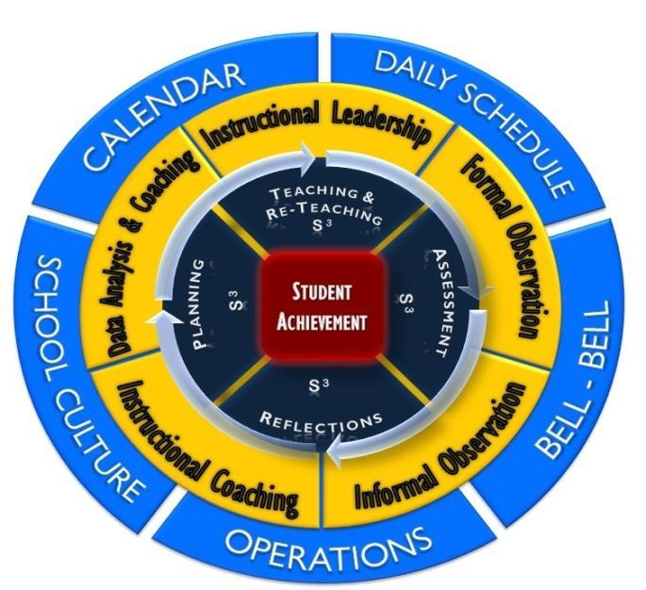

**Figure 15. The Gap-Closing Framework**

As discussed in Chapter 5, the standard public school year of 180 days, with a 6.5-hour school day, provides insufficient learning time to cover all of the benchmarks and standards that students are expected to learn. Consequently, at Harvest Prep and Best Academy, both the school year and school day have been expanded. This ensures sufficient learning time and thus maximizes student achievement. It reflects an emphasis on the fundamental question, What do students need to maximize achievement? Harvest Prep and Best Academy worked backwards to make sure that all of the supports, systems, and structures were in place to meet those needs.

By expanding the school year, another obstacle for low-income students was removed: the summertime learning gap. A 3-month vacation is appreciated by teachers, but it jeopardizes the progress of students, particularly those who are further behind and in the greatest need. No other profession commands the 4 months of vacation afforded to teachers (3 months of summer vacation, 2 weeks of winter/Christmas break, 1 week of spring/Easter break, and a week of other holidays interspersed throughout the year). While there has been union resistance to reducing the summer vacation for teachers, a compromise has been achieved by some high-performing schools: extend the school year, while interspersing vacation time more evenly throughout the year at 1–2-week intervals. This has proven effective in increasing student achievement and avoiding the summertime learning gap.

In many public school districts and schools, however, the educational framework operates in just the opposite manner. Administration starts with the school calendar, daily schedule, and operations, and then tries to figure out how to fit everything into those fixed structures. Instead of changing the size of the educational box by adding more learning time, administrators and teachers are forced to work within a time structure that has proven inadequate and ineffective. Hearkening back to the words of former Minneapolis Public Schools Superintendent, Dr. Carol Johnson, “In our public education system, time is justice. What is enough time for some, is not enough time for others.”

In sum, these structures do not help solve the educational challenges that economically disadvantaged and minority children face—children who start kindergarten behind and fall further behind through the years. These children need more time to get caught up, not less time.

Schools and school districts that have proven effective in closing the achievement gap design the structure around the vision, mission, and goals in order to optimize student achievement. To reiterate: Student achievement comes first and everything else revolves around that. Student achievement is at the core of the gap closing framework.

## 

## Inner Ring One: The Teaching Cycle

The first ring around student achievement is the Teaching Ring. The cycle within this ring proceeds in the following order: Planning, Teaching & Re-teaching, Assessments, and Reflection.

### 

### *Planning*

Planning addresses the first of the five essential questions set forth at the beginning of this chapter: What do my children need to know and be able to do? Planning comes first in the process, before teaching, assessment, reflection and student support systems. Actually, planning also includes each of these items.

State academic standards provide the guidelines for developing curriculum at Harvest Prep and Best Academy. In every subject area, teachers must ensure that all benchmarks in the state standards are met before year’s end.

The link from the state standards to instruction is created by backwards planning. It means starting with the standards established by the state department of education for each subject area and then developing curriculum based on each benchmark that the student is expected to master at that grade level. For example, a 3rd grade reading standard might consist of a student being able to understand “Key Ideas and Details” of a short story. One of the benchmarks under this standard is, “Students will be able to ask and answer questions to demonstrate understanding of the text, referring explicitly to the text as basis for the answer.” An important distinction in the planning for teachers is that they must also determine the level of rigor required to master the standards that will be assessed.

***The Yearly Pacing Guide***

After a grade-level team of teachers has determined all of the benchmarks and standards that students will have to learn for the year, a pacing guide is established. The guide indicates when any given benchmark will be taught during the school year and how many academic days will be spent covering that benchmark. It can change and be updated throughout the year, but a working draft is available before the first day of school begins.

***The Term Pacing Guide***

After the yearlong pacing guide is established, the term guide is developed. It is a more detailed and comprehensive version of the Yearly Pacing Guide. Not only does it include when a benchmark will be taught in the course of the school year, it also what indicates the resources that will be used to teach the benchmark and how the benchmark will be assessed to ascertain if students have learned the information. The Term Pacing Guide focuses on one term’s progress, highlights the standards or benchmarks to be taught during that term, lists the days they will be taught and the daily objectives of the lesson, and addresses any prerequisite skills or knowledge students need to have before they are able to master the benchmark at grade level.

***Weekly Lesson Plans***

##### As the teacher moves forward in the planning process, the planning becomes more detailed. Weekly Lesson Plans enable instructional leaders to develop their plans more thoroughly to deliver academic content that is rigorous and engaging. Grade-level teams divide up lesson-planning responsibilities based on the individual strengths of the team members.

Lesson planning spirals backwards from interim formative assessments, which are created by grade-level teams prior to the beginning of each term. An interim formative assessment is a rigorous test given in class every 6-8 weeks to determine if students have retained the information from past and current benchmarks. In Minnesota, for example, all tested benchmarks for grades 3-8 must be covered by April 1st of each year, when statewide (Minnesota Comprehensive Assessment) testing occurs. For kindergarten through second grade, teachers have the full year to cover grade-level standards. Backwards planning answers the question, What do my students need to know and be able to do?

##### In planning lessons, Harvest Preparatory School and Best Academy extensively use the book, *The Skillful Teachers*, by Jon Saphier, Mary Ann Haley-Speca, and Robert Grower. The authors outline 21 planning decisions involved in lesson planning that are highly recommended to all teachers and school leaders. We will not go into these 21 planning decisions, except to say that the first 13 are called basic and indispensable decisions, and the last 8 are called implementation decisions.

### 

### *Teaching and Re-teaching*

Teaching and Re-teaching addresses the second of the five essential questions set forth at the beginning of this chapter: What are the most effective ways to teach what they need to know?

It’s not uncommon to believe that we are successful in all things that cannot be measured. The same principle applies in teaching. Teachers tend to believe they are more successful in their teaching, when the results are not measured. At Harvest Prep and Best Academy, success is evaluated by how successful students are mastering the standards that are being measured. Thus, the goals of teaching and re-teaching are as follows:

* To cultivate a growth mindset in all students
* To have students master the benchmarks set by the Minnesota Department of Education as well as the national benchmarks in reading, writing, math, science and social studies at all grade levels
* To have students make a year or more of academic growth by the end of the school year
* To have all of students (grades 3-8) meet or exceed the standard on the Minnesota Comprehensive Assessments
* To have 100% of students (grades 2-8) make their target growth goals on the Northwest Education Assessment (NWEA)
* To prepare students for college
* To develop students to use good moral judgment and be positive contributors to society and have desire to give back to their community.

All of these goals are directly measureable. At each step along the way, a quantifiable answer can be given for each and every student. The period is longer, of course, for college bound students; it’s also longer for determining whether students are showing good moral judgment and making positive contributions to society. But it is still quantifiable.

Teaching addresses the question, What are the most effective practices to teach whatever students need to know? This question is answered by using the best research on effective instruction available and by giving the teacher extensive professional development. Instructional leaders facilitate ongoing professional development on effective and engaging instructional strategies and by ongoing use of strategic data systems.

### 

### *Assessments*

#### Assessments addresses the third of the five essential questions set forth at the beginning of this chapter: How do I know if they got it?

At the classroom level, there are three timeframes in which to implement re-teaching strategies based upon assessments: daily, weekly, and end-of-term.

### Daily Exit Slips

The teacher can use Exit Slips (a question or series of short questions to determine whether students understood the subject matter being taught) on a daily basis or at the end of a lesson to determine whether students have mastered the daily objective. This is the quickest way to find out whether an individual student or classroom of students would benefit from some type of re-teaching. A quick analysis of the exit slip can tell the teacher which skill the student is missing. The teacher is given time during their 70 minute preparation period to review Exit Slips and homework assignments, in order to adjust the next day’s lesson. If more than one student has the same problem, the teacher can group the students together and offer a mini lesson covering the strategy or step that those students missed. If many students had the same problem, the mini lesson can be taught to the whole group. This skill can also be spiraled into the homework, and the Do Now for the following day. Once again, by planning how classroom time will be used, sufficient time can be set aside to allow for student grouping or differentiation.

### Weekly Quizzes

At the end of each week, the teacher gives a quiz. The quiz is aligned to the benchmarks covered during the week. The daily school schedule gives the teacher time to develop and grade the quizzes. At Harvest Prep and Best Academy, students leave school early every Friday to allow teachers time to analyze quiz and other testing data. After the quiz is given and graded, the teacher fills out a tracker that shows how each student performed on each question. This tracker is a systematic way to determine which skills need to be retaught and to which students. The re-teaching happens the following week using strategies like mini-lessons to small groups, differentiated independent work, homework, and Do Nows. If 80% of the class does not understand a particular benchmark as evidenced by exit slips, homework and weekly quizzes, then the benchmark must be retaught to the entire class. On the other hand, if only a few students that haven’t mastered a particular benchmark, then the benchmark can be retaught during the intervention period mentioned earlier. Students who master the benchmarks on the weekly quizzes should be offered differentiated work that will push them further.

### Comprehensive Interim Assessments

At the end of the term, which is usually every 6 to 8 weeks, the teacher will administer a Comprehensive Interim Assessment, also known as a COMP. The COMP covers all of the benchmarks taught during the 6–8-week term. Teachers in grades K-8 administer the COMP’s and then fill out a tracker that shows student performances during that period. The weekly and COMP trackers let teachers and administrators know whether students are on track for meeting the state standards. The school then provides teachers with a Data Day at the end of each term to analyze the information and plan a reteach week. The Data Day is usually the Friday at the end of the week that students have taken their COMPS. On Data Days, the students are released from school, but the teachers come to school to analyze data from test results. In order to be more efficient and actually use the data being generated, Harvest Prep and Best Academy use an automated scanner that takes the test information from students’ scores and provides a high-level analysis of the data. The scanner automates as many of the teacher functions as possible to create efficiencies. Time that teachers would otherwise use for grading and logging these interim assessments can now be used for analysis of the data.

Teachers then take this data and determine by grade level, class level and individual student level what kind of consistent patterns are occurring. Did the whole grade level get some question wrong? For example, if there are four 3rd grade classes, data analysis will show which class did the best, which did the worst, and where the discrepancies are occurring.

The most important part of the Data Day is for teachers to develop re-teaching plans based on the data. The week following the Data Day is set aside to reteach skills that were not mastered. Depending on the number of students who did not master the subject matter, re-teaching will be done either in small groups or with the entire class. It is the job of the grade-level team to determine what activities and lessons will be covered to address the needs of all learners.

With independent work, exit slips, and weekly quizzes, a teacher should know which students are proficient on the benchmarks, even before the COMP’s are administered. These tests are collectively referred to as continuous formative assessments*,* and are critical in providing teachers and administrators with up-to-date data for grading and establishing a teaching and re-teaching roadmap for the teacher to follow.

### 

### *Response to Intervention/S3*

#### What If Students Didn’t Learn the Material After I Taught It?

Gap closing schools use a Response to Intervention (RTI) model to provide additional support to students who are behind. In the Gap-Closing Framework illustration, RTI is symbolized by S3 or Student Support System. RTI is the practice of providing high-quality instruction and interventions that match students’ needs; and using students’ learning rate over time and level of performance to make important educational decisions.

The theory of RTI is that 80% of students should be supported by the curriculum provided to all students. For the 20% of students who may not be successful with the standard curriculum (or *Tier 1* program as it is called), a system of interventions are set up to address students that are right below grade level (i.e., at *Tier 2*) and students that are far below grade level (i.e., at *Tier 3*). A 50-minute intervention block for *Tier 2* and *Tier 3* students is built into the school schedule to address the students’ individual needs. For students in elementary school, the intervention may occur during regularly scheduled class time, assuming there are teaching assistants or support in the classroom. For students in middle school, the intervention may be done by a different teaching intervention specialist and in a one-on-one or small group setting.

### 

### *Middle Ring 2: Administrative Support to Teachers*

### *Instructional Leadership*

The purpose of Instructional Leadership is to ensure that student learning time is maximized through teacher professional development. Professional development includes four major categories: data and assessment, planning, classroom management, and core instruction presentation. Instructional leadership is supported by building administrators, teacher leaders (coaches) and/or educational consultants.

Every teacher is assigned an instructional leader or coach to help develop and strengthen their instructional effectiveness. Administrators will track student performance results and then assign teachers to administrators, educational consultants, and teacher support based on grade level and subject expertise. Instructional leaders will provide a half hour of feedback based on a 20-30 minute informal observation, every other week, or on an as needed basis. Instructional leaders meet with teachers and complete a Teacher Learning Plan, which is revised every term (i.e. five times throughout the school year). This practice was adopted at Harvest Prep and Best Academy after school leaders attended a training conducted by Dacia Toll, co-founder of Achievement First charter school management organization.

### *Formal Observation*

The system for formal observations is derived from Achievement First,[2] Driven by Data, and the System for Teacher and Student Advancement Program (TAP).[3] The lesson plan format is Madeline Hunter’s framework.

Instructional leaders use formal observations to determine staff development needs and to determine additional incentive pay. Teacher performance is evaluated on a scale from 1 to 5: 1 (*poor*), 2 (*below average performance*), 3 (*proficient*), 4 (*above* *average*), to 5 (*exemplary*).

Formal observations are conducted three times a year to evaluate a teacher’s overall performance. In order to receive incentive pay, a teacher must have a 3.0 average on their formal observation (see the appendix for the rubric). The formal observation process consists of:

1. A pre-meeting to discuss the teacher’s lesson plan
2. An 45–60-minute observation
3. A post-observation meeting with the teacher
4. A follow-up in teacher learning plan

### 

### *Informal Observation*

Much in the same way a swimming coach improves a swimmer’s technique by being at the pool to observe swimming during lessons, practice, and swim meets, *Driven by Data: A Practical Guide to Improve Instruction*, by Paul Bambrick-Santoyo,[4] has heavily influenced the notion of being “at the pool” to give teachers feedback on their teaching.

You can’t improve a swimmer’s technique by reading about their performance in the newspaper the next day. The coach must be “at the pool” providing feedback to the swimmer minute by minute. This feedback might include form, stroke rate and efficiency of turns. Bambrick-Santoyo uses this as a metaphor to describe the school leader’s role in improving instruction for students through the teachers. Instructional leaders can’t improve student achievement by reading about the results of the state testing results in the newspaper. Instructional leaders can’t change student outcomes just by reviewing internal testing data. They must be “at the pool” or in the classroom providing teachers valuable feedback during or immediately after a lesson.

The purpose of informal observations is to give teachers immediate and continuous written and verbal feedback on their instructional practices in specific areas. Informal observations focus intentionally on goals set in the Teaching Learning Plan and assume that the area of focus will change frequently as the teacher improves.

Informal observations are unannounced; they last for 20-30 minutes and occur frequently throughout the year. Feedback is emailed to the teacher and the teacher meets with the Instructional Leader biweekly to discuss progress. The process goes as follows:

1. Conduct a 20–30 minute biweekly observation based on phase focus [define]
2. Inform the teacher immediately afterward via email (a teacher may respond and/or provide an explanation if needed)
3. Give informal verbal feedback biweekly for 20-30 minutes based on phase focus

A copy of the informal observation document is included in the Appendix.

### *Data Analysis & Coaching*

The development of the data analysis and coaching used by Harvest Prep and Best Academy was highly influenced by two books: *Driven by Data* by Paul Bambrick-Santoyo and *The Data Coach’s Guide to Improving Learning for All Students: Unleashing the Power of Collaborative Inquiry*, by Nancy Love, Katherine Stiles, Susan Murphy, and Kathryn DiRana.as well as by visits to high-performing charter schools from around the country, such as Roxbury Prep in Massachusetts. Materials from Achievement First’s instructional framework were incorporated into the design.

The purpose of this section is to describe how teachers use data at Harvest Prep and Best Academy, and how the instructional leaders or coaches facilitate data meetings with both grade-level teams and individual teachers.

Teachers and administrators analyze data during three timeframes: daily, weekly, and every 6–8 weeks. Teachers meet with coaches weekly to review the data. Teachers have all three levels of assessment information available before they plan and teach lessons.

Daily analysis of student performance is done through exit slips, where students are asked to produce a product that aligns with the day’s objective for that subject. Information from exit slips is used to plan future whole- and small-group instruction. The intent is to grade the exit slips the same day or for the next day, in order to inform the next day’s lesson and instruction.

Weekly quizzes are given on Fridays to determine how students are progressing on the benchmarks. In grades K-4, quizzes are written for both mathematics and reading. For grades 5-8, each subject area teacher (mathematics, reading, science, and social studies) quizzes students on the benchmarks taught that week. All of these quizzes are common among all classes at each grade level. That data is then analyzed the following Friday afternoon.

Finally, a cumulative and formative assessment is given every 6–8 weeks (COMP) to assess how students have progressed over several benchmarks. Staff in grades 3-8 use a Scantron machine and bubble sheets to collect testing information; they use software, called Prosper, which allows for multifaceted student-level reports aligned to the benchmarks. Full data days at the end of each COMP period are dedicated to data analysis, reteach week and unit planning, as well as individual data meetings with administration and coaches. Teachers use a Cause and Verification form for every COMP assessment to determine root causes of performance. Student interventions are then planned on an on-going basis throughout the school year. A data manager works with teachers to (a) facilitate managing student-level data; (b) to create and maintain up-to-date student trackers; and (c) to use the Scantron machine. The data manager ensures that the technical pieces of the data process are in working order.

Coaching on data is done weekly during grade-level team meetings. Teaching and administrative staff analyze common quiz data using a tracker system that displays students’ overall scores, student’s individual scores, and scores by individual benchmark items. The tracker gives coaches information on how individual students are doing and what interventions they may need. It also gives teachers and administrators information on how any given class is doing on a given skill or concept. Individual data meetings occur every data day or five times a year. The individual data meeting goes over the data for each teacher’s classroom. Teachers meet with their coach and go through an in-depth analysis of how their students are doing. They are expected to attend these weekly meetings and be prepared to discuss their quiz data.

Such meetings provide an additional layer of accountability, as teachers meet one to one with administrators and teacher leaders (Instructional Coach) to ensure all students succeed in all areas assessed.

Every Friday is a half day of school for students. Data days, following *COMP exams,* are mapped out on the master school calendar as full days of professional development. The personnel responsible for administering and conducting these data days are administration, coaches, teacher leaders, and a full-time data manager.

At the beginning of every school year, new staff is trained on the data analysis system. Modeling of individual data meetings and training on data management is demonstrated by experienced teachers, coaches and administrators to ensure that teachers understand what is expected of them and what the process looks like. All staff is required to read *Driven by Data* as part of their individual professional development.

## 

## Outer Ring 3 - School Structural, Operational, and Cultural Supports

### *School Calendar, Bell to Bell, and Daily Schedule*

The school calendar sets forth the total number of days the school plans to be open, the total number of hours it is in operation, and the total number of instructional hours that are available. In the Harvest Prep and Best Academy model, there are 195 school days, and 9 hours per school day. This equates to 1,755 total hours the school is open for business. School starts at 8:00 a.m. and ends at 5:00 p.m. The longer day and year provide students with over 35% more time in school than the typical public school district (172 days of school for students with a 6.5-hour school day for a total of 1,118 hours). The additional 35% more time each year has a positive and cumulative academic effect on students. It gives them the ability to catch up academically if they are behind, and reduces the backslide that takes place for low-income children during the summertime learning gap. The longer school day and longer school year provide the school with the ability to individualize support using RTI to meet the needs of students and to give teachers more time to prepare lessons and analyze student data.

Given the additional amount of time that is available, Harvest Prep and Best Academy students have 1 additional year of educational advantage over the typical public school student for every 3 years that a student spends in this educational system. This means that a student who starts in kindergarten at Harvest Prep or Best Academy and stays continuously enrolled through the 8th grade, will have a 3-year academic advantage over the typical public school

At the Best Academy school, we conducted a satisfaction survey to be completed by parents/families. The results of the survey inform us that the majority of our families are satisfied with their schools academic program.

The survey measured parent/family satisfaction in the following areas:

* Service Excellence
* Communication excellence
* Operational excellence
* Teacher and school leadership excellence (academic)
* Overall Satisfaction

In our parent/family survey, we asked Best Academy School families the net promoter question: “I will recommend another parent or family for their child to attend the Best Academy School.” (Exhibit 1) The net promoter is a survey question that helps organizations gauge the loyalty of its parents/families. The survey results show that the majority of parents are Promoters.

During the 2014-2015 school year, the decision to shorten the 2015-2016 school day and the year was proposed. We administered a survey to the HNS parents. The results of that survey inform us that the majority of parents/families agreed with the changes made.

**Management**

Add Seed management contract

**BIO for Eric Mahmoud**

Eric Mahmoud has more than 20 years of hands-on experience in educational administration. His commitment to academic excellence is reflected in his passionate pursuit of policies and programs that support teachers, empower parents, and inspire students. He believes, fundamentally, that all children deserve, and must receive, a high-quality education.

Mr. Mahmoud is Founder and CEO of Seed Academy, Harvest Preparatory School, Best Academy, Sister Academy and Mastery Schools. He served as principal of Best Academy from 2008 – 2015.

At Harvest Preparatory and Best Academy, he is responsible for fundraising, financial management, public relations, organizational accountability, facility management, and management of state compliance and accountability. Under his leadership Harvest Preparatory and Best Academy are the top schools in the state of Minnesota in closing the academic achievement gap between white and African American children. In 2011 and 2012, the Star Tribune recognized Harvest Preparatory School as the number one school in the state of Minnesota that is “Beating the Odds”. In 2011, Best Academy 8th grade all-boys program tied for first place in the state for 8th grade reading and Best Academy 3rd grade all-boys program tied for first place in the state of Minnesota for 3rd grade math. In 2011 and 2012, Best Academy all-boys 3rd through 8th grade program closed the achievement gap by outperforming the state white student average in reading and math. Best Academy was ranked number 1 in the state of Minnesota for high poverty schools based on the states Multiple Measurement Rating (MMR).

Eric has received both local and national recognition for his work in education. In 2012 the University Of Minnesota recognized Eric with its **Dean’s Outstanding Achievement Award**. In June 2012, Eric was inducted into the **National Charter School Hall of Fame**. In October 2012, the Minnesota Business Partnership recognized Harvest and Best Academy with its **Minnesota Futures Award**. This award is given to the top two schools in the state of Minnesota. In April 2013 Best Academy received national recognition from the Coalition Of Schools Educating Boys Of Color (COSEBOC). COSEBOC awarded Best Academy with its **National School Award** as one of the top five schools in the nation in educating boys of color. Lastly, on January 21, 2013 General Mills and the MLK Breakfast Committee recognized Eric Mahmoud as a **Minnesota Local Legend**.

Eric has recently developed “The Five-Gap Analysis”, which parses the achievement gap into five gaps that schools must address in order to close the education gap. He has also developed the “Gap-Closing Framework”, which provides a coherent and aligned educational model to accelerate student learning. Both of these bodies of work are featured in Eric’s new book, ***BEST IN CLASS: HOW WE CLOSED THE 5 GAPS OF ACADEMIC ACHIEVEMENT***. Eric and his network of schools was featured in Soledad O’Brien’s Black in America series in August 2013.

**Ms. Fatou Diahame**

Ms. Diahame (“Ms. Fatou”) was born in Senegal, West Africa. She moved to the United States in 1999 to teach French. After a year in a French program she sought employment at Harvest Prep in 2000 and has been here ever since. She has a Bachelor’s degree in English and is finishing her Master of Arts in Instruction at Saint Mary’s University.

As a teacher at both Harvest Preparatory and Best Academy for 15 years her rigorous standards for quality instruction have set a high standard.

Ms. Fatou has taught grades K-4, in 2011 and 2012 her 4th grade boys outscored the state average in reading and math.

She is currently Principal of Best Academy K-8.

|  |  |  |  |  |
| --- | --- | --- | --- | --- |
| **Best Teaching staff** | | | | |
| **Name** | **File #** | **License/Assignment** | **2015-16 Status** | **Comments** |
| Ahmadzai, Muhammad | 482261 | K-12 ESL/ ESL | R |  |
| Addink, Keandrea | 480581 | K-6 Elem/ 1st Grade | NR |  |
| Becker, Raquel | 480229 | K-6 Elem/ 2nd Grade | NR |  |
| Becvar, Brian | 387989 | 7-12 Math/ Math | NR |  |
| Bergstrom, Lisa | 401777 | K-6 Elem/ 2nd Grade | R |  |
| Burrows, Brittany | 473867 | K-6 Elem/ 4th Grade | R |  |
| Byron, Katheryn | 479231 | K-6 Elem/ 4th Grade | R |  |
| Cain, Leonard | 997303 | K-12 EBD/ K-4 EBD | R | NLCE license |
| Colon, Jennifer | 476586 | No license/ K-4 EBD | NR |  |
| Coins, Michelle | 441333 | K-6 Elem/ 5th Grade | R |  |
| Duffy, Alyssa | 482018 | B Grade 3/ 1st Grade | NR |  |
| Durkee, Rachel | 997395 | K-12 ESL/ ESL | NR | NLCE |
| Fetter, Elizabeth | 453882 | K-6 Elem/ 5th Grade | R |  |
| Fields, Lenora | 431581 | K-12 EBD/ 5-8 EBD | NR |  |
| Groothuis, Molly | 478094 | K-6 Elem/ K Teacher | R |  |
| Hall, Loretta |  | No License/ 5th Grade | NR | Highly Qualified |
| Hamilton, Susan | 476073 | 5-12 Math/ Math | R |  |
| Haukos, Joseph | 451977 | 5-12 Social Studies | R |  |
| Hechtman, Noelle | 453025 | 5-12 Language Arts | R |  |
| Huss, Paula | 404819 | K-12 EBD/ K-4 EBD | NR |  |
| Hussain, Samina | 396906 | K-6 Elem/ 5th Grade | R |  |
| Jahnke, Jennifer | 434551 | B Grade 3/ 3rd Grade | R |  |
| Jarvis, Mariecus | 482887 | 5-8 Science/ Science | R |  |
| Johnson, Alicia | 446812 | K-6 Elem/ 2nd Grade | R |  |
| Kelley, Kathryn | 448029 | K-12 ESL/ ESL | R |  |
| Kuennen, Jessica | 477965 | K-6 Elem/ 5-8 EBD | R |  |
| LaFollette, Kristine | 478157 | K-12 ESL/ ESL | R |  |
| Lenarz-Wyatt, Elizabeth | 472464 | K-12 Music/ Music | R |  |
| Lis, Mikhail | 417015 | 5-12 Math/ Title 1 | R |  |
| Mack, Paul | 451032 | K-12 Visual Art/ Art | R |  |
| Mann, Justin | 483625 | 5-12 Social Studies/ 8th | NR |  |
| Mark, Katlynne | 481497 | K-6 Elem/ 2nd Grade | NR |  |
| McGuire, Molly | 405691 | 1-6 Elem/ 2nd Grade | NR |  |
| Monson, Meghan | 311676 | K-6 Elem/ 5-8 EBD | NR |  |
| O’Donnell, Meghan | 474454 | K-6 Elem/ 3rd Grade | R |  |
| Olsen, Keilly | 443500 | K-6 Elem/ Title 1 | R |  |
| Pangerl, McKenzie | 464222 | 5-12 Health/ Health | R |  |
| Porter, Brandon | 475563 | K-12 EBD/ K-4 EBD | NR |  |
| Ratliff, Taylor | 997048 | 5-8 Math/ science | NR | NLCE |
| Reed, Ruth | 475607 | 5-8 Science/ Science | NR |  |
| Roegge, Meghan | 475584 | 5-12 Language Arts/ 6th Grade | R |  |
| **Name** | **File #** | **License/Assignment** | **2015-16 Status** | **Comments** |
| Rohde, Anna | 472829 | 7-12 Language Arts/ 7th Grade | R |  |
| Selcer, Danielle | 475614 | K-12 ESL/ ESL | R |  |
| Snyder, Amanda | 474439 | K-12 Music/ Music | NR |  |
| Summer. Tara | 452569 | Short Call Sub/ Building Sub | R |  |
| Troy, Tia | 480509 | 5-8 Science/ 5th Grade | NR |  |
| VanBronkhorst, Elizabeth | 473633 | B Grade 3/ K Teacher | NR |  |
| Vickery, Kimberly | 445654 | K-6 Elem/ 1st Grade | NR |  |
| Voorhaar, Britta | 478791 | K-12 Visual Arts/ Art | NR |  |
| Walker, Jennifer | 396123 | 1-6 Elem/ 4th Grade | R |  |
| Weed, Meghan | 482234 | K-6 Elem/ 1st Grade | NR |  |
| Weispfennig, Scott | 442255 | K-12 PE/ PE | NR |  |
| West, Holly | 445543 | K-6 Elem/ K Teacher | R |  |
| Wilson, Amanda | 478715 | 5-12 Math/ Math | NR |  |
| Wright, Abdul | 471908 | 5-12 Language Arts/ 8th Grade | R |  |
| Wright, Kathleen | 471029 | 1-6 Elem/ 3rd Grade | NR |  |

*Recruitment:*

The Best Academy approach for staffing is to: Post all positions internally first then externally to ensure current staff can advance their career, as well as recommend qualified individuals from their communities. It is a practice of The Best Academy School to post positions externally for seven to ten business days on traditional education job posting sites as well as with local college institutions.

*Selection:*

Our selection process is to prescreen all qualified candidates; we present the top candidates to the Principals and hiring managers for interviews. We perform our interview with a panel of leaders and subject matter experts. All candidates are scored with a candidates appraisal form to minimize confirmation bias; then the final candidate is selected.

With non licensed candidates, we follow the prescribed steps to request a variance or limited license from the governing body.

How Recruitment supports the school Mission and Student Achievement:

We select the qualified candidates who closely aligns with our Organization Culture, Mission, and Vision.

**2015-2016 New Best Academy School Licensed Teaching Staff:**

|  |  |  |  |
| --- | --- | --- | --- |
| **Last name** | **FFN** | **License/Assign** | **Comments** |
| Bentley, Brittany | 482905 | K-6 Elem/ 2nd Grade |  |
| Watson, Hannah | 486713 | K-6 Elem/ 3rd grade |  |
| Winkels, Claire | 483106 | K-12 EBD/ K-4 EBD |  |
| Mazone, Deanna |  | Not licensed | License pending completion of test |
| Lynch, Dillon | 488168 | 5-8 Science | Limited license |
| Hanson, Blair | 456314 | 5-12 Math/ 6th Math |  |
| Ross, Danae | 487294 | 5-12 Language Arts/ 7th Grade |  |
| Patton, James | 475600 | 5-12 Math/8th Grade |  |
| Ziesmer, Veronica | 487058 | K-12 LD |  |
| Folken, Christian | 488894 | Short Call Sub/ Teaching Assistant |  |
| Maxwell, Holly | 488473 | K-6 Elem/ 1st grade |  |
| Burns, Kelsey | 487500 | K-6 Elem/ 2nd Grade |  |
| Knutson, Amy | 471577 | License pending | TFA Teacher |
| Hunholz, Molly |  | K-12 LD | NLCE |
| Lu, Joan | 463690 | K-12 ESL/ ESL |  |
| Sheen, Heidi | 411207 | K-12 ESL/ ESL |  |

Provide a brief narrative discussing the teacher turnover rate. Include trend data from previous years as appropriate.

The Best Academy teacher turnover rate is 41% compared to last year of 31%. The 10% difference is due to adding additional staff to reflect our current growth strategy.

|  |  |
| --- | --- |
| **Percentage of Licensed Teachers from 2014-15 not returning in 2015-16** | **41%** |

2014-15 Other Licensed (non-teaching) Staff:

|  |  |  |  |
| --- | --- | --- | --- |
| **Name** | **License and Assignment** | **15-16 Status** | **Comments** |
| Brosz, Adam | K-12 School Social Worker/ Social Worker | R |  |
| Buckner, Maya | K-12 School Social Worker/ Social Worker | R |  |
| Gaikwad, Elsa | K-12 School Counselor/ Guidance Counselor | R |  |
| Christofferson | K-12 School Psychologist | NR |  |
| Propes, Beverly | K-12 School Nurse/ Nurse | R |  |

**2015-16 Other Licensed (non-teaching) New Staff:**

|  |  |  |
| --- | --- | --- |
| **Name** | **License and Assignment** | **Comments** |
| MacQueen, Kelsey | K-12 School Counselor/ Guidance Counselor |  |

**2014-15 Non-Licensed Staff**

|  |  |  |  |
| --- | --- | --- | --- |
| **Name** | **Assignment** | **15-16 Status** | **Comments** |
| Abdi, Mohamed | Education Assistant | R |  |
| Abner, Eboni | Paraprofessional | R |  |
| Aden, Zakaria | Paraprofessional | R |  |
| Ali, Mamdouh | Behavior Interventionist | R |  |
| Anderson, Gillette | Behavior Interventionist | R |  |
| Anderson, Isaac | Education Assistant | R |  |
| Anderson, Wendy | Due Process Secretary | R |  |
| Askar, Abdimalik | Outreach Coordinator | R |  |
| Ballard, Otis | Maintenance | R |  |
| Barnes, Jay | Bus Aide | R |  |
| Berry, Thomas | Education Assistant | R |  |
| Briscoe, Sundia | Receptionist | R |  |
| Brooks, Augustus | Student Teacher | R |  |
| Burns, Sean | Teaching Assistant | R |  |
| Coleman, Courtney | Paraprofessional | R |  |
| Crutcher, Howard | Behavior Interventionist | R |  |
| Daniel, MyChoice | Paraprofessional | R |  |
| Davie, Merrill | Bus Aide | R |  |
| Elaydi, Mouna | Paraprofessional | R |  |
| Ellis, April | Paraprofessional | R |  |
| Goering, Sharena | Paraprofessional | R |  |
| Harvey, Adhyrtle | DI Assistant | R |  |
| Hassan, Seyfu | Paraprofessional | R |  |
| Hayles, Korrey | Behavior Interventionist | R |  |
| Holliday, Joshlin | Bus Aide | R |  |
| Jackson, Marnika | Education Assistant | R |  |
| Jama, Jawahir | Receptionist | R |  |
| John, Valerie | Education Assistant | R |  |
| Johnson, Joyce | Paraprofessional | R |  |
| Jones, Robert | Academic Interventionist | R |  |
| Langford, Markel | Education Assistant | R |  |
| Millbrooks, Samantha | Transportation Coordinator | R |  |
| Muhammad, Jason | Behavior Interventionist | R |  |
| Pratt, Marlon | Academic Interventionist | R |  |
| Roan, Jamarri | Education Assistant | R |  |
| Ross, Christopher | Paraprofessional | R |  |
| Russell, Troy | Education Assistant | R |  |
| Simmons, Charlotte | Education Assistant | R |  |
| Thorpe, Kante | Paraprofessional | R |  |
| Walker, LaNisha | Paraprofessional | R |  |
| Walton, Javeon | Paraprofessional | R |  |
| Williams, Brittany | Education Assistant | R |  |
| Williams, Rashawn | Paraprofessional | R |  |
| Worthor, Theodore | Behavior Interventionist | R |  |

**2015-2016 Non-Licensed New Staff:**

|  |  |  |
| --- | --- | --- |
| **Name** | **Assignment** | **Comments** |
| Abdul, Sahroayan | Bus Aide |  |
| Abukar, Farida | Bus Aide |  |
| Ali, Saido | Bus Aide |  |
| Allen, Robert | Education Assistant |  |
| Eckford, Tommy | Maintenance |  |
| El-Amin, Taheera | Education Assistant |  |
| Folken, Christian | Education Professional |  |
| Hayow, Faisal | Educational Professional |  |
| Isse, Abdimajeed | Maintenance |  |
| Jama, Safia | Bus Aide |  |
| Jones, Amber | Academic Interventionist |  |
| Khalfan, Bakari | Education Assistant |  |
| Knox, Vincent | Education Professional |  |
| Mohamed, Hawo | Bus Aide |  |
| Mohamud, Ismahan | Bus Aide |  |
| Shannon, Dawn | Academic Interventionist |  |
| Vickers, Charles | Director of Student Culture |  |
| Voris, Quincy | Education Professional |  |
| Williams, Lewis | Maintenance |  |
|  |  |  |

**15. Future Plans**

*Provide a brief narrative on key strategic areas for the school moving forward. Could include, but not limited to:*

**Expansion plans**

Best Academy enrollment increased from 480 in 13/14 to 628 in 15/16. Please see attached Harvest Network of Schools Business Plan, which includes future plans for Best Academy.

**Facility changes**

Best East K-4 continues to operate in the 1300 Olson Memorial Drive facility. Best Academy K-8 is now located at 2131 12th Avenue North, Minneapolis.

**Program changes**

In response to the 14/15 MCA scores, Best Academy will place a greater emphasis on the core subjects of reading and math, ending the school day at 3:45 p.m. in order to add an hour of after-school intervention focused on reading and math for grades 3- 8. Grades K-2 will end the day at 3:45 p.m.

**Technology updates**

A technology plan has been developed for the entire Network with a goal of providing one device per student. Please see attached for details.

**Attachment:** HNS Technology Plan

All Schools Projection by Year

HNS Business Plan

1.
2. Achievement First is a network of public charter schools, incorporated in 2003, serves over 7000 students from low income and ethnic minority backgrounds who have achieved outstanding results in New Haven, Bridgeport and Hartford, Connecticut and Brooklyn, New York.
3. TAP was founded by Lowell Milken in 1999 to significantly improve teacher recruitment, retention, motivation, practices and performance.
4. Bambrick-Santoyo, Paul, *Driven by Data: A Practical Guide to Improve Instruction, John Wiley & Sons, Inc. 2010, Josey-Boss, San Francisco, CA.*